**IoT Networking &**

**Safety and Comfort in Smart Vehicles**

**CS 6290 Networks & Distributed Processes**

**Project Documentation**

**Students:**

**Aakanksha Mahajan, Anusha Allu**

**& Sampath Yelchuri**

**Academic Supervisor:**

**Dr. Hassan Rajaei**

**Fall 2018**

**Department of Computer Science**

**Bowling Green State University, Ohio**

**IoT Networking and Smart Vehicle**

**Students:**

**Aakanksha Mahajan, Anusha Allu**

**& Sampath Yelchuri**

Supervisor: Dr. Rajaei

Dept. of Computer Science

Bowling Green State University, Ohio

Reporting date: 12/13/2018

**Abstract**

In the present day, Smart Vehicles are equipped with cutting edge technology making the vehicles intelligent, more safe and secure on roads. 5G Radio Access networks and the mobile edge computing have helped expand the horizons in the field of connected cars. Tesla, BMW, Mercedes and Chevrolet are the leading manufacturers of Smart Vehicles with the main objective of how to make driving easy, safe and comfortable for the drivers and the passengers.

Safety and comfort are the foremost goal for the smart vehicles. Vehicles have sensors which help monitor and control them and enhance the safety and comfort for all the passengers. This paper investigates research area of safety and comfort of all passengers in the smart vehicle. Passengers should feel comfortable and at ease even if there is some failure has occurred in the IoT based Smart vehicle system. We assume that safety concern leads to uncomfortability and therefore these 2 topics go hand in hand. There must be way if the network or communication is cut off. The passengers of the vehicle should not wait for support and fix for hours. Artificial Intelligence and Big Data Analytics bring a drastic change providing services to the users with the best experiences. Safety and Comfort for a child is also one of the areas for research in this paper. This paper will provide solutions for better safety and comfort using 5G, Mobile Edge Computing, Big Data Analytics, Artificial Intelligence wit better architecture design.

**Table of Contents**

1. Introduction 1

Goals and Objectives 1

Overview of the Topic 2

Research Questions 2

Expected Results 2

2. Related work 3

2.1. Summary of Reviewed Work 3

2.2. Analysis and Discussions 6

What has been done? How good it has been done? 6

What has not been done? What needs to be completed? 6

What differentiates current work from related work? 6

2.3. Highlights of Current Contribution 7

3. IoT and Networking Essentials 7

3.1. IoT Key Features 8

3.2. IoT Key Phases 9

3.2.1. Data Collection 10

3.2.2. Data Transport 10

3.2.3. Data Processing 11

3.3. Mobility and Wireless Connectivity 11

3.4. Mobile Edge Computing 13

3.5. Fault Tolerance 15

3.6. Future Trends 16

3.7. Open Issues 17

4. Safety and Comfort in Smart Vehicles 18

4.1. Safety and Comfort 19

4.2. Security and Vulnerability 21

4.2.1. Data Protection 23

4.3. System Reliability and Fault Recovery 24

4.4. Child Safety and Comfort 30

4.5. Future Trends 33

5. Case Studies, Examples, and Analysis 34

6. Project Steps 40

6.1. Phases and Efforts 40

6.2. Research Methods used by the Project 43

6.3. Project Strengths and Limitations 43

6.4. Lessons Learned 43

7. Proposal for Future Work 44

8. Conclusions 44

9. References 45

This page is left intentionally blank

### Introduction

Internet of Things (IoT) can be defined as a system of interrelated, inanimate devices over internet with the ability to communicate with each other without the human intervention [1]. IoT makes our life easier by associating our everyday functionalities to internet and thereby relying on its communication and computation capabilities. The smart world was fictional earlier and now it is becoming a reality because of Internet of Things. Smart Vehicles being one of the IoT application was one of the primary applications with high importance. It is predicted that by the end of 2020, there will be 250 million Smart cars connected to each other in the IoT system. Urbanization in rapidly increasing and so is the pollution in the environment and congestion on roads. Smart Vehicles aim on having an energy efficient, environment friendly and low accident transportation in the city.

With the presence of 5G and Mobile Edge Computing, and the existence of Vehicle-To-Vehicle and Vehicle-to-Infrastructure architectures in vehicles we today can foresee the presence of driverless, autonomous vehicles. Smart Vehicles tend to improve the intelligent transport system guaranteeing safety, comfort, effortless driving and systematic driving with very low accidents. The sensors that are equipped in the Smart Vehicles collect huge amount of sensing data and then is stored and processed at real time for quick responses and decisions using Artificial Intelligence and Big Data Analytics. This kind of analysis helps in making decisions for the driver in case of failure of any IoT based devices in the platform. Please note we have assumed that failure and unsafe situations cause discomfort to the passengers in the vehicles and therefore we focus on these 2 topics: Safety and Comfort parallelly.

## Goals and Objectives

Smart cars are fancy, semi-autonomous and energy efficient. But are they safe? This paper is completely based on how to provide safety and comfort to all the passengers in the car. The full development of connected cars leads us to autonomous vehicles. The ubiquitous connectivity of in-vehicle computing systems and improvements in vehicle-to-vehicle and vehicle-to-infrastructure architectures enhances the contextual awareness in autonomous vehicles and furthermore guarantee safety and comfort of drivers and passengers [2].

*Main Objectives of the paper are listed here:*

1. Answer a set of research questions listed under Research Questions section below, based solely on Safety and Comfort for all the passengers in the Smart Cars.
2. Introduction to the integration of IoT and Smart cars application with the key phases of Data Collection, Processing and Analytics.
3. The significance of Mobile Edge and Ubiquitous Computing and how to provide the continuous connectivity and provide more comfort to the passengers.
4. Discussions on the reliability and performance aspects of Smart Vehicles.
5. Discuss the various technologies used for implementation of the Smart vehicles to provide safety and comfort and discuss a few case studies which will help with the understanding.
6. Comparison and analysis of the Expected and Achieved Results for the Research Question in this project.

## Overview of the Topic

The focus will be how the Smart cars will behave in case of failure because failure recovery is one of the prime aspects for a continuous functioning of the Smart cars without any dangers posed to the driver or the passengers in the car. AI and data analytics can enhance comfort and safety in the cars with the high ability of making correct decisions and with the real time data analysis and monitoring. We know that child safety has been investigated and there are multiple safety measures that need to be taken care when child is present in the car. Integrating child safety in smart car and IoT platform is another major area of analysis focusing towards the maintained temperatures in the car, no dangerous gas emissions that can harm the child need to be taken care.

5G is the driving factor for Smart Vehicles connectivity to another vehicle or infrastructure, or any other Smart infrastructure. 5G will help in better vehicular mobile networking with very low latency, extremely high bandwidth and better reliability [3]. 5G can provision massive device connectivity, Quality of Experience and Reduced costs [4]. The paper introduces a new architecture for 5G enabled vehicles based out of the combination of Software Defined Networks and Mobile Edge Computing providing benefits to the communication between the vehicles and the infrastructure and the computing capacity as well [5]. Indirectly all the connectivity leads to better safety and comfort for the passengers in the vehicles.

## Research Questions

RQ1: Safety and Comfort of all passengers in Smart Car

RQ2: How to improve failure recovery in Smart car when loss of network

RQ3: How to use AI and Data Analytics to quickly respond to recovery of failure

RQ4: How can Smart Vehicles improve Child Safety and Comfort

## Expected Results

As the primary focus of the paper is Safety and Comfort for all the passengers in the Smart Vehicles, we tend to add more improvement in the same field. We will be focusing on failure mechanisms and how we can safely and comfortably recover from loss of network or connectivity while the passengers are in the Smart Vehicles and driving. We will be trying to propose new ways of child safety, protection and comfort in different scenarios. With integration of Artificial Intelligence and Big Data Analytics in the Smart Vehicles, we will present analysis on how they can provide better safety and comfort to the driver by better monitoring and decision making in case of failures as well.

### Related work

In this section, we tend to report the literature worked upon earlier related to Safety and Comfort for the drivers, the passengers and the children in the Smart Vehicles. We then closely analyze the research work to our intended ideas and improvement in the solutions to the existing work that we are trying to make and how the related work helped us through our research.

### Summary of Reviewed Work

A lot of researches are happening in creating intelligent vehicles making use of the latest technologies and keeping the foremost motive as safety for the passengers in the Smart vehicles. The paper [34] by C. B. S. T. Molina et. al. discusses about diminishing the accidents on road which typically can happen due to driver errors and the not so perfect autopilots. They talk about the ISO 26262 standard which lists down the standards for building autonomous vehicles. The authors propose a new strategy for assuring safety in the vehicles which is an independent component called Autonomous Vehicle Control (AVC). This module interacts with the vehicle system. Drivers, environment and the sensors used for monitoring individually and is believed to make safe decisions at run time without driver or any human supervision. It is also believed to provide safety standards and add to the existing ones in the vehicles. As per the architecture, AVC module consists of 2 sub modules called Autonomous Vehicle Operation (AVO) and the Autonomous Vehicle Protection (AVP) which are independent modules. AVO is responsible for monitoring the health of the vehicle and the various system variables and tries to detect any kind of abnormality. AVP on the other hand is responsible for all data processing and makes decisions on how the vehicle behaves if there is any error. This paper helps answering RQ1.

For high level of comfort for all the passengers in the smart vehicle it is important take care of multiple environmental parameters like the Oxygen levels and rise in temperature level. This paper [35] aims to develop a monitoring system to play a role of protecting and safekeeping the passengers inside the vehicle. There needs to be special monitoring required for various gas levels like oxygen and carbon dioxide because lowers level of oxygen can lead to fatigue and can also lead the driver to drowsiness. This may have a huge impact on causing fatal road accidents. It is also believed that Exhaust Gas Suicide can happen due to the exposure of poisonous gases entering the vehicle. There is no hesitance of taking pets and children in the vehicle these days and this adds another safety issue. There have been many incidents reported related to the deaths of children and animals in the vehicles because of heat strokes. This can occur because of increase in temperature levels inside the vehicle. This paper aims at developing a smart monitoring system for oxygen levels, multiple gas emissions, temperatures and humidity as well. Thereby making sure of comfort, health, security and safety of passengers in the vehicle. This question helps in supporting our solution to Research Question 1.

Autonomous vehicles have been developed by Uber, Tesla and others. With the recent accident of Uber autonomous vehicle, it is evident that the safety and comfort of the passengers and the pedestrians is still at risk. *Hafiz Halin et. al* [36] have given a design of a controller which can accurately decide depending on the environment. This fuzzy controller collects data with factors like speed, steering wheel angle and position and body of the human while driving through designed paths. This is done in human navigation experiment. This data helps in forming the fuzzy member functions of the controller. Then simulations are done to analyze the performance of the fuzzy controller. With this study, it shows that the maximum steering wheel angle and time taken for each human is different but of similar characteristic. This results in the path tracking error. Small path tracking error which is the output of the controller gives us an idea that the fuzzy controller is reliable. Their study and their simulation results help in future to get maximum performance and minimum path tracking error. This will help to reduce the accidents in the autonomous vehicles. Hence, the passengers of the autonomous vehicles are safe avoiding any accidents. This paper will help us to answer *RQ1*.

*Walton Fehr et. al* in their research [25] have discussed about an architecture that helps in communication of vehicles with the road or street side infrastructure entities which have the capacity to communicate and process data which is being transmitted. This methodology enables vehicles to know about their current state, behavior and can speak with other mobile vehicles using the road side entities. Each vehicle is embedded with a centralized unit which is used for storing and computing the vehicular data which needs to be communicated with the other vehicle(s) centralized unit. These centralized units are in turn connected to the roadside infrastructure which are treated as an interface for the communication purpose. Moreover, this framework also exchanges information regarding the current location and speed of the vehicle with the other nearby vehicles which helps in maintaining the safety or ensures that the vehicles do not collide with each other which are moving at a great speed. This one helps to further provide insight towards Research Question 2.

According to *Guiyang Luo et. al* [26], all the current architectures that are introduced are based on the centralized models. The main reason for the use of the centralized models is to maintain synchronicity, consistency and they being economic. Due to this centralized architecture it becomes very difficult to reduce problems like resource management, load balancing and high rate of data transmission etc. which lead to latency issues, lag in response times, etc. A decentralized framework using edge computing has been designed in order to overcome these kinds of issues. It is also suggested to have both centralized and decentralized frameworks where the decentralized frameworks cannot handle various tasks efficiently and they are quite inflexible when compared to the centralized frameworks. They make use of Vehicular Ad-hoc Networks (VANET) for heterogeneous communication. The proposed architecture also uses the new 5G technology and Software Defined Networking (SDN) concepts in order to ensure good coordination and communication. This certainly gives the foundation for the RQ2.

*Jonghyuk Kim et. al* in the paper [6] have conducted practical implementation of applying real time big data analytics in connected cars with successful results. Their model included the collection of different kinds of sensed data, store on the Hadoop clusters and perform real time analysis while streaming the data. The insignificant variables are removed, and statistical analysis is further performed on the important significant data. Using this real time analytics, we can identify various important parameters of the car and driver and other conditions like mechanical characteristics, over speeding, oxygen levels, drivers’ behaviors etc. Hypothesis models are created, and all data is checked against the model. If there is any variation, then we can identify something is wrong and can alert the passengers which will ultimately help with safety and comfort for the passengers in the car. This helps in providing solutions to the *Research Question 3*.

The paper [31] by Lusian Sasu et. al. talks about the importance of fault recovery mechanisms in smart city environment and tries to help answer the *Research Question 3*. There are various components like the sensors, actuators etc. which can fail in real time and needs to undergo fault detection and fault recovery from such situations. They propose an architecture of failure component for a Smart City framework. The architecture makes use of artificial intelligence algorithms. They evaluated 3 incremental learning models which are Local Learning model (KNN), linear model trained with stochastic gradient descent and IKNN model. The failure recovery component is trained with valid and safe data first and thus the learning model can analyze the unexpected behavior if there is any discrepancy or failure. Further, then the estimated value is figured out by the self-learning system to try and make the system operational again. The incremental learning model is not only quick in response time but also has the ability of the prediction model to quickly identify the changes in the data.

C.Mohamedaslam et.al in paper [29], have proposed a system where security of vehicles and human beings is improved and to reduce accidental injuries. They used vehicle sensing mechanism to track speed and few other parameters of the car which will automatically send message to nearby traffic police using GPRS technology. In this paper, they have taken control over speed, seat belt, door, obstacle detection and to be the complete safety and security of the vehicle. They have a vehicle black box for driver assistance and alert, which stores the various sensors outputs. Various sensors will help to detect any flaw happening in the vehicle system and immediately warn the related authorities to get immediate first-aid. Arduino Mega 2560 is the microcontroller board used in their proposed model. This is the most important part of their vehicle sensor system. This will receive the data from various sensors like seat belt sensor, temperature sensor and eye blink sensor. This system will have output in 2 ways, alarm and LCD. LCD shows message about increase in speed and alarm sounds when driver shuts his eyes. In this way, paper gives an idea of how safety and security can be achieved using their proposed system. This paper helps answer RQ4.

The paper [30] by M. Vinoth et.al propose a design for the car safety seat using thermoelectric cooler. Due to prolonged time in the car, the body temperature increases and increase the risk of child injuries and deaths This paper gives a solution for temporarily protecting the occupants in the car. A seat occupant sensor and thermistor will help in their system to detect unsafe temperature rise. Thermoelectric cooler helps to maintain the temperature in the parked vehicles for two hours. They have done the experiment considering different climatic conditions and different parking places. This way, their proposed model provides safety of passengers especially the children and the handicapped people. This paper helps answering RQ4.

Ashraf Gaffar et.al [] have done a research in brain-computer interaction (BCI) and how this technology may be used to improve the interaction between human brains and the automobiles. They have given few predictions how this technology can be used in the autonomous vehicles. Their research says this investigates comfort of each passenger in the car. Without logging on, there would be personalized interaction between each passenger. There will be no physical input. Everything would be visual BCI interfaces. Users in the car can access whatever they need from the internet with heads-up display. Cars might be able to wirelessly monitor neural patterns of the passengers and the intentions are mapped to the neural data. Individual safety and comfort will be looked upon by the new upcoming technology. Communicating with the car happens virtually in the mind of the passengers. This paper helps answering RQ4.

### Analysis and Discussions

The literature reviews have helped gaining a new perception towards how to go about looking into each research area applicable to this paper. We read about the issues faced and the general idea about the Safety and Comfort and the different models available for maintaining high standards of safety and comfort for passengers in the vehicle. Not only this, how various upcoming technologies like SDN, 5G, NFV, Artificial Intelligence and Data Analytics are paving way to solve the questions being answered in this paper.

We found literature on how 5G and Mobile Edge Computing and the concept of Internet of Vehicles are highly important to maintain the mobility of the Smart Vehicles. There are a few use cases where it has been seen that children have been involved in the accidents due to heat stroke inside the vehicle and the driver and the others do not get to know about it. Also, child safety is one of the upcoming research areas. Another research area for this paper is fault recovery using Artificial Intelligence and Data Analytics. There have been a lot of research going on in advancements in the field of Artificial Intelligence and Data Analytics and this was a good start to approach the answer for the research towards fault tolerance and recovery using these technologies.

## What has been done? How good it has been done?

The literature has provided good ideas to approach the specific research questions that we have in our paper. The available upcoming technologies discussed for all the 4 research questions are advancing and need more focus. These are the current and latest areas which need to be focused for providing more comfort and safety for the passengers in the vehicle and face effortless driving.

## What has not been done? What needs to be completed?

The concept and ideas have been proposed in the research paper related to the questions and implementation of those ideas presented are not complete. There still needs to be more research required for verification of the ideas. There are no simulation results supporting the work. For future work it will be required to investigate further in the technologies proposed that can be worked upon to implement solutions.

## What differentiates current work from related work?

We have provided new approaches to different questions or something in addition to what already is present. Our ideas may be new and helpful for the future work as well. Our ideas if employed for Smart Vehicles, we can help provide more safety and comfort for the passengers in the vehicles. In addition to what has already been presented, we try to provide more additions or better approach as per the questions answered in this paper.

## Highlights of Current Contribution

1. High Connectivity, low latency and reliable network infrastructure can ensure safety in Smart Vehicles.
2. Smart Vehicles are highly time sensitive as we are talking about real time monitoring and control not only in case of providing comfort to the passengers but also fast recovery response in case of failures.
3. Importance of mobility, ubiquitous and mobile edge computing for failure recovery and ensure safety and comfort for the passengers in the Smart Vehicles.
4. Artificial Intelligence and Real time data analytics can help avoid accidents and help safety during failure in the IoT systems.
5. Child safety and comfort can be ensured in Smart Vehicles with implementation of solutions for multiple use cases mentioned in the paper.

### IoT and Networking Essentials

Smart vehicles communicate with each other and the infrastructure in order to perform various services in order to achieve automation in the Smart vehicles. Services include real time weather, road conditions, real time updates on traffic, etc. In Smart Vehicles, all the services are time sensitive and if there is any delay in any kind of update and it can lead to dangerous failures and result in accidents and wrong decisions by the systems in the Smart Vehicles. Therefore, it is important to have a reliable and robust networking architecture. The inter communications among the smart vehicles need to implement heterogeneous networks like Wireless Sensing Networks, 3GPPRANs and non-GPPRANs and new 5G networks which provide Radio Access networking and Virtual Core networks which help in connectivity among the vehicles itself. The connectivity must be maintained or should be able to create communication between the pedestrian mobile devices as well as smart home gateways as well [13]. All these networks together ensure low latency, less dysconnectivity from the internet. Further it leads to very high throughput and faster failure of service recovery as well. As our paper focuses on safety and comfort for all the passengers in the Smart Vehicles, the different communications in the network are achieved with the help of the concept of network slicing. The Multi-Tenant Controller architecture defined in the figure 1 helps to meet the requirement. Below provides you one of the latest and reliable architectures for Smart Vehicles in the heterogeneous network based on SDN (Software Defined Network) and NFV (Network Virtual Functions).

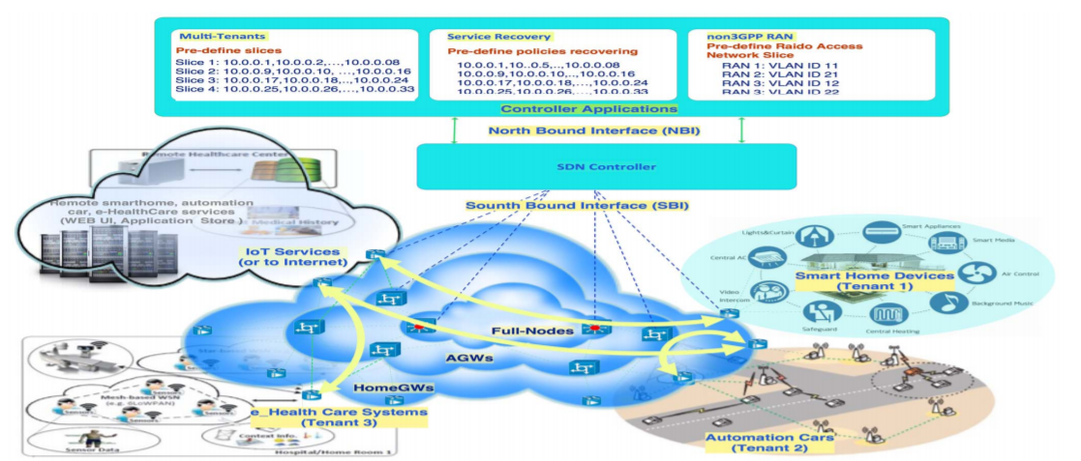

**Fig. 1: SDN/NFV Architecture for Internet of Things [13]**

### IoT Key Features

Internet of Things is not a concept of single technology but an integration of multiple heterogeneous technologies to build a smart application. The key basic characteristic of IoT are [15]:

1. **Interconnectivity**: This feature corresponds to the connectivity of different kinds of technology connected to each other and the communication infrastructure between all the objects.
2. **Things related services**: Different services should be provided by the devices based on their constraints like privacy related, identity related, information collecting, ubiquitous services, etc.
3. **Heterogeneity**: Different objects and devices connected to each other come from different platforms, a different hardware or different language implementations from different vendors.
4. **Dynamic changes**: Different objects in IoT tend to change states, and the whole system must be able to dynamically update itself to accommodate those changes.

**Table 1: Mapping of IoT requirements with latest available technologies [15]**

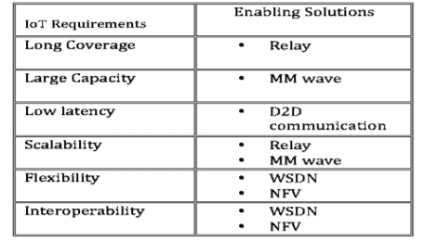

The above Table 1 gives us a clear picture of the requirements to achieve an overall reliable IoT Smart Application and what latest technologies can be used to achieve those requirements.

### IoT Key Phases

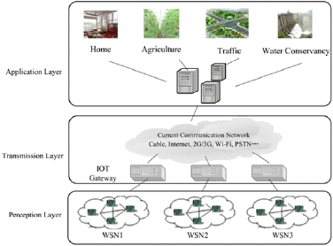

**Fig 2: Three important IoT phases in Smart Vehicles [9]**

The three most important phases of Internet of Things are illustrated in the above Fig 2:

1. **Data Collection** projected by Perception layer
2. **Data transport** over the network using the Transmission Layer
3. **Data Processing** and providing feedback to the associated Smart Applications illustrated by the Application layer

### Data Collection

Data collection is the most important part in the Internet of Things. Perception Layer collects process the information collected from the outside world. Sensing is a part of it. Data is collected from two parts that is the sensor devices and the wireless sensor networks. This layer has wide range of sensors like temperature and humidity sensor, RFID label, camera, geographical location sensor. Data must be gathered from the sensed data of all the nodes in the sensor network. The main technologies used in this are signal detection and sensor networks. It is expected that the number of sensors will be 200 per vehicle by 2020 [17].

**Table2: Connected devices in billions [15]**

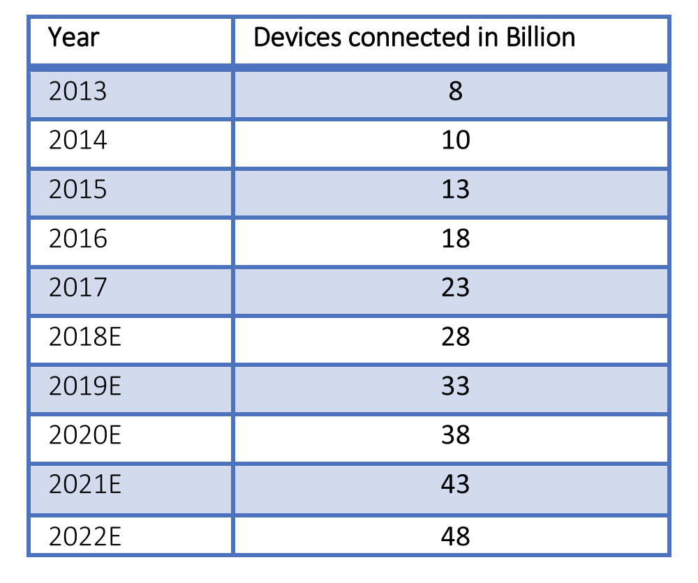

Due to the increase in the benefits of IOT, the society is slowly accepting the smart devices. From the Table 2, we can see that the connected devices increase day by day and this implies data collection also becomes more critical. Researchers [15] have mentioned that there might be 48 billion devices connected by the year 2022. Collecting the data from huge number of connected devices is a challenge. If we take smart vehicles, it has many heterogeneous sensors, data must be collected in a uniform way.

### Data Transport

The data collected must be transported for processing. In the transmission layer, it has got different networks including the internet, communication network and the cloud computing or the edge computing platform. Different types of data are collected in this process. Data must be securely transmitted from sensor devices to the information processing systems. The mediums used for transport are WiFi,4G or 5G, Zigbee etc. The network layer acts as the transport medium between perception layer and the application layer.

If cloud computing is used to transfer the data of the sensors sent from the vehicles, the responses from the cloud will be delayed and quality of service is not guaranteed which will not be helpful for realistic applications [16]. For this, it is good to consider edge computing platform to transport the data. The main aim of fog/edge computing is that it increases the efficiency by reducing the amount of data transported to cloud to process, analyze and store the data.

### Data Processing

Data processing takes place in the application layer. Application layer acts as the interface between the users and the Internet of Things. The data received from the transport layer is handled by different systems in this layer. Different technologies used in the systems can be data mining, cloud computing and many other intelligent technologies to process different types of data. As seen in the Figure 2, the applications of Internet of Things are vast. They can be used for home, business, agriculture, traffic, environment and so on.

Edge Computing is used in the data processing phase. The reason behind this can be explained with an example. In smart vehicles, if we consider driverless cars, it requires high performance computing. The processing of the data happens nearby rather than sending the data to the cloud. This way real time actions can happen easily. For example, the decision to hit the brakes or to speed up must happen very fast. For this, edge computing plays an important role because if car will not receive the data simultaneously, the implications can be tragic. So, the applications require response times less than milliseconds and this implies that the data processing must happen rapidly.

### Mobility and Wireless Connectivity

In today’s world, Wireless communication and Mobility plays a crucial role in providing safety and comfortness of the user(s) in the field of IoT and Smart Vehicles. It is being observed that day by day and year by year, the rate of using the IoT devices is getting increased. This quick development of IoT devices and applications like Smart Vehicles can communicate with each other through a common medium of internet. Keeping a view on the passenger(s) comfortness and safety in a Smart Vehicle which may occur in different environments and situations, it is impossible to handle all of them using a single standard of wireless communication. There are a wide range of standards which support Wireless Communications which have already been implemented in the outside world. These include increase in the bandwidth for enhancing faster communication, using various wireless protocols like TCP/IP, Controller Area Network (CAN) and selecting an appropriate routing algorithm for effective and reliable communication between various other IoT devices and entities for maintaining comfortness and safety of the user(s) or passenger(s) who are travelling in the Smart Cars.

In order to establish Wireless Communication between any two or more systems, there are some predefined standards which must implemented for proper transmission of the data. The most traditional and basic model for Wireless Communication is the Open System Interconnection (OSI) model. This model works on the concept of splitting up of the entire communication seven layers which uses several simple protocols. The availability of cloud and antennas are fit for sharing information among various nodes both inside and outside the vehicles. The usage of sensors can create a safe and secure level of driving by ensuring the drivers experience.

With increase in the amount of data generated by the IoT devices embedded in a Smart Vehicle and the need for instant responses in critical situations like providing safety of passenger(s) even if there is any failure in the communication between the two systems or IoT devices and has made latency as a key issue as the vehicle is moving at a great speed. The current use of 4G as a communication platform in Smart Vehicles has provided few advancements in the implementation of Connected Cars. But one of the key drawbacks of 4G is that, the transmission of the data in the form of wavelengths from the Smart Vehicle initially must be sent to the cell tower and then from there it must be transmitted to a base station. This was because of the reason that the 4G technology did not have higher bandwidths which could support for the Smart Vehicles.

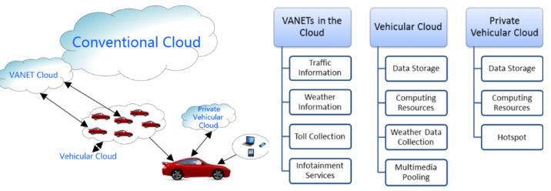

**Fig. 3: Cloud-5G-VANET Architecture providing high wireless network bandwidth and mobility [7].**

The newly emerging 5G technology enhances the challenge of maintaining user(s) or passenger(s) comfortness and safety with the help of Vehicular Ad-Hoc Network (VANETs) [5]. With the help of 5G-VANETs, some of the crucial issues like increase the delay in the rate of processing data and decrease in the delays of data transmission can be achieved. It is essential to integrate the concepts of Software Defined Networking (SDN) and Cloud Computing to implement 5G-VANETs. The reason behind using SDN as a key concept is that, it is a kind of approach helps separation of network control from data transmission which can be used for achieving effective communication between the systems. Moreover, it is also possible to create a Private Vehicular Cloud [7], where it can be developed using the inbuilt IoT devices in the Smart Vehicle that gives driver(s) a small storage capacity and connectivity. This enables drivers in the Smart Vehicles not only making their data available readily but help in classifying the ownership of the data as shown in Fig 3.

There are two solutions for V2X communications:

1. Dedicated Short Range Communications (DSRC): wireless technology for autonomous and intelligent transport system for short range exchange of data. Eg. On-board Units, roadside units, devices with pedestrians.
2. Long Term Evolution (LTE) cellular network technology supporting Vehicle-to-Everything (V2X) terminology. Different V2X communications are illustrated in Fig. 4 [11]:

* Vehicle-to-Vehicle (V2V) Communications
* Vehicle-to-Network (V2N)
* Vehicle-to-Infrastructure (V2I)
* Vehicle-to-Pedestrian (V2P)

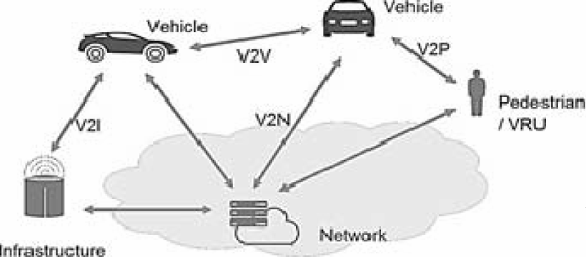

**Fig. 4: Mobility in Smart Vehicles by V2X communications [11]**

### Mobile Edge Computing

So, today when we talk about Mobile Edge Processing where many people think of Smartphones or some other IoT systems. But, in current scenario, Edge Processing technology is helps Smart Vehicles in providing efficient communication between two or more systems where communication plays a key role for maintaining the safety of the passenger in a Smart Vehicle. Edge computing offers services like running any operations of engine controls, safety mechanisms and many more functions. Mobile Edge Computing is also responsible for providing many safety features in Smart Vehicles like Anti-Lock Braking System (ABS), Collision Avoidance System, Adaptive Cruise Control and many more which can be implemented by using the concept of Edge Processing in real time. Mobile Edge Computing utilizes data that is being continuously generated by the IoT devices, but still the Smart Vehicles does not have enough capability to use this data extensively.

In Fig. 5, according to K.Kai [10], Edge Computing or Fog Computing offers services which aims at reducing the latency and improving Quality of Service (QoS) to its users by staying at the end of the network. Edge Computing uses the concept of Software Defined Networking (SDN) which plays a key role in in the implementation process.

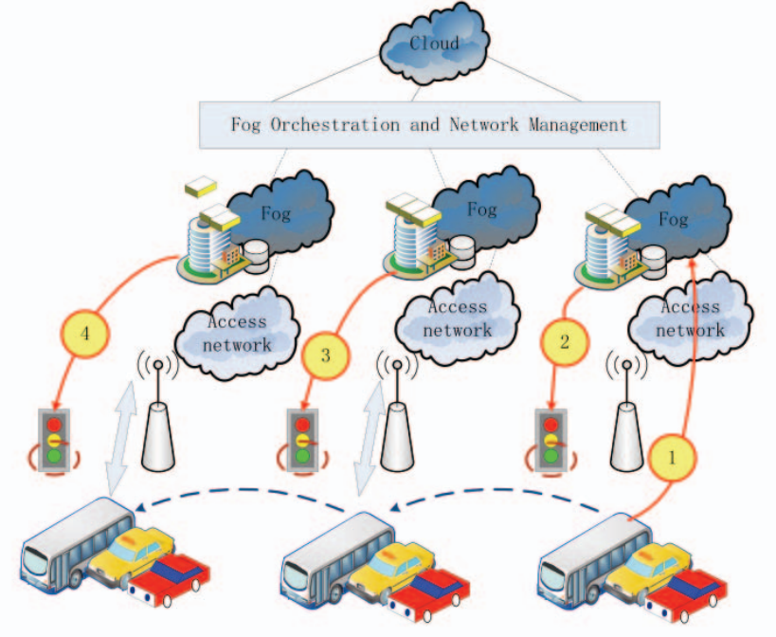

**Fig. 5: Smart Vehicles Connected to Fog and Cloud [8]**

Edge Computing incorporated with SDN and VANET architecture is helpful in operating Smart Vehicles in different environment of network. It helps in establishing V2V and V2I communication. To implement this model the following SDN components are required [10]:

1. Controller: It is defined as the master or head of all the networks and governs all the networks. It plays a key role in managing the resources in the Fog.
2. Wireless Nodes: The Smart vehicles are denoted as the end users and treated as the message or data forwarding element to the other nearby Smart Vehicles as well.
3. Roadside Unit (RSU): It is termed as an Edge Computing device which can be considered as an infrastructure which is controlled by SDN Controller.
4. Roadside Unit Controller (RSUC): RSCU is a collection of RSU which are interconnected with each other for communication using SDN Controller.
5. Base Station (BS): This Base Station helps in overall communication of Smart Vehicles with others Smart Vehicles or Infrastructure where the SDN Controller manages all the services offered by Edge Computing.

### Fault Tolerance

Failure occurrence is very common in vehicles and fault detection and recovery in mobile nodes is quite challenging. In case of mobile vehicles, there are major 3 kinds of faults that occur; Firstly, network or communication error, second is in vehicle, component like sensor or actuator not working and another is human error leading to accidents. Now all of this involves 3 discussions when we talk about failure which is applicable to any kind of a system; Fault Detection, Fault Tolerance and Fault Recovery. Today we can get fast real time updates and suggestions on the go in vehicles because of the infrastructure set up of the edge nodes. There has increased the concern of safety and expectation of having fault tolerant vehicles.

There is an increase in safety-related electronic systems in vehicles that are directly responsible for vehicle safety. Now in Smart vehicles we take the control away from the driver and it is expected that the vehicle is driven with utmost safety. Therefore, it is expected to solve faults as well. This paper gives an overview of the strategies that are highly useful in the automotive environment to guarantee high degree of fault tolerance both for 2 case scenarios being considered in the paper:

1. When there is network or communication loss of the vehicle with the infrastructure: There is always a need of a reliable communication. Lots of implementations have been deployed to the vehicle system for highly safe and reliable network communication of the vehicle with the infrastructure. This case has already been discussed under section 3.3 Mobile Edge Computing where Research Question 2 has been tried to answer.
2. When there is fault in vehicle components like sensor or actuator or if there is a possibility of accident occurring: Artificial Intelligence and Data Analytics are rising technologies. Many researchers are giving high importance to the work towards the advancement in these technologies and how well they can be used for converting the vehicles into a successful full-fledged autonomous vehicle. How artificial intelligence and Data Analytics for fault tolerance and recovery in vehicles making it smarter is further discussed under subsection 4.2.

Now also there are some functions which need to diagnose the fault occurred in the vehicle and even need to be able to precisely date and time them. This can be achieved by deciding a global synchronized time base for the vehicles. One major design issue is again to use AI and data analytics. AI helps to fix things at real time with very low jitters with high bandwidth availability. Another useful technology is Data Analytics which will help make the system fault tolerant even better. This will however ensure that at run-time no errors will put the vehicles in danger. And therefore, only time-triggered communication systems are being considered for use in safety critical applications.

### Future Trends

A couple of decades back, individual vehicles and navigation system was totally reliant on paper guides that nobody at any point realized how to overlap! Advanced digital maps are one of the examples of how innovation has totally changed our reality. A Smart Vehicle can be treated as an advanced generation vehicle which is furnished with huge number of actuators, sensors and controllers [21]. Using these sensors, actuators and controllers the Smart vehicles are designed in such a way that they maintain driver(s) comfort and safety. To achieve this, a new technology and architecture Intelligent Connected Vehicle (ICV) has been introduced in place of traditional architecture.

The Conventional design of a non-autonomous vehicles supports only the manual driver(s) where he/she must control each and everything. For example, sometimes it becomes very difficult for an architecture of a non-autonomous vehicle to handle a large portion of data which is being produced by the driver(s). The present modern vehicular systems mainly work on the principle of centralized gateway-based communication. Here the gateway is placed at the center of the entire system which acts as the single cluster for communication between all other clusters that are available in the vehicle.

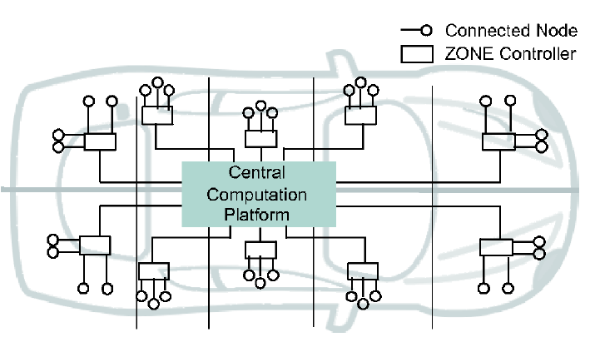

**Fig. 6: Centralized Architecture [21]**

With the advancement in the car innovations, particularly the improvement of independent driving, all the components that are connected in the vehicle need to transmit and receive more information. So, this Centralized architecture has a drawback of processing and handling data of all the connected components in the vehicle.

One of the methodologies is to separate the controllers into a few groups based upon their functionality, which is known as the Domain Based Architecture [22]. Here each domain has its own unit for control which helps communication between the other domain control units with a high data processing power. This kind of separation of controllers does not require huge amount of bandwidth which increases the communication speed and responsiveness while making internal decisions.

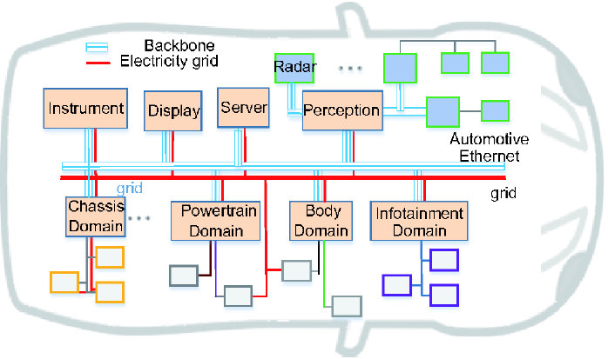

**Fig. 7: Domain Based Architecture [21]**

### Open Issues

Vehicles speaking with the outside world as begun in the year 1996. Significant number of sensors and actuators are utilized in Smart vehicles to detect the physical movements of things which are outside and inside the vehicle. The main objective of Smart vehicles is to solve the traffic related problems, fuel efficiency, collision avoidance and maintain the driver and passenger(s) safety and experience [23].

The major concern of issue rises mainly due to the network and delay in the communication between the different components which are connected in the Smart vehicle. The below given Figure 8 indicates the integration of vehicle network.

***Problems***:

* There is loss of information which is being generated in the unconnected vehicles that must be coordinated with the information that is being generated by the connected vehicles.
* Due to the high mobility of the Smart vehicles, there might be some scenarios whenever a light or a sound wave travels between the two or more vehicles, the wavelength may be increased or decreased due to the relative movement of the other Smart vehicles (Doppler Effect).
* It is very important to keep on changing the route of communication which is known as the topology of as network.
* Due to the requirement in the change in the topology of the network, there are changes of dysconnectivity. And this dysconnectivity may result in issues like transmitting data etc.,

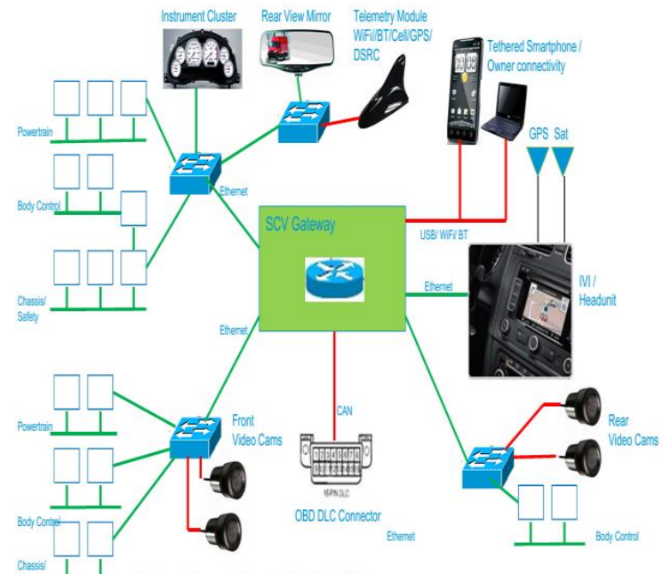

**Fig. 8: Integration of vehicle network [23]**

***Challenges:***

1. One of the major challenges is to incorporate the heterogeneous IoT devices in to Smart vehicle.
2. Building up a Smart and Intelligent Transportation System (ITS) is challenging task.
3. Data which is being produced from various sensors of the connected vehicles as to be synchronized.

### Safety and Comfort in Smart Vehicles

The increase in number of sensors, processors, cameras in smart vehicles increase the need of data transmission reliably and there is a need of high bandwidth and low-latency. Performance of the system relies on the factors high bandwidth and low- latency. Autonomous driving, failure of timely braking may not be possible if the bandwidth is low. Message rate must be more to avoid collisions or disasters. Along with this, security plays an important role. There are chances of information breach and unauthorized access to systems in vehicles. There is a need for semiconductor reliability too. For example, overheating in the system may lead to non-functioning of sensors in the vehicles which will help to guide that there is some obstacle or a pedestrian behind the vehicle.

### Safety and Comfort

The below diagram gives the high-level view of the monitoring system and the flow of data collection and operation.

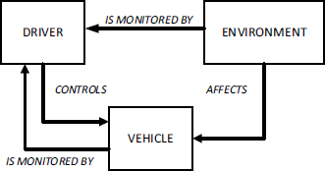

**Fig. 9: High Level Diagram of monitoring system [34]**

In general, in a vehicle, the driver is the one that monitors the vehicle and the environment and solely takes part in controlling the vehicle and making decisions. This feature or concept is the same for the fully or semi-autonomous vehicles also. The only difference is that the driver is not human, it is the machine. This is what is illustrated in the Figure 9.

Dynamic Driving Task (DDT), is an existing system defined by SAE looked by authors of the paper which keeps an eye on the functionality for running operation on road while driving. They described their analysis and figured out 3 main efforts that need to be put for driving safely.

1. *Strategic* which involves operations related to trip planning, best routes to choose, etc.
2. *tactical* involves maneuvering the smart vehicle in traffic during a trip, selecting correct and lawful speed, etc.
3. *operational* involving operations related to steering, breaks, acceleration while lane change in traffic and while avoiding dangerous event in the pathway.

The Figure 10 shows the high-level diagram for the AVC component. DDT comprised of the Sensing Sub-system, Perception Sub-system and Control Subsystem together as a component.

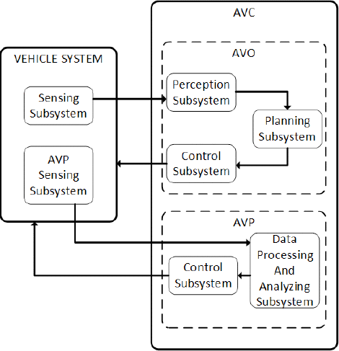

**Fig. 10: AVC component working the vehicle [34].**

Functionalities of the DDT module have been explained in order to show the modules can run and operate the vehicle autonomously. Now presenting details of how exactly the AVC system fits in the vehicular system and interacts with the vehicle. The high-level diagram expresses the operation of AVC in the Fig 10. AVC system defined in the paper is an independent module in the computing system which provides modularity and this component then can be used in any vehicle. It consists of 2 main sub modules i.e. AVO and AVP. AVO is the sub-module which reads the data coming from the different kinds of sensors in the vehicle. The vehicle has 1000s of sensors sensing different kinds of data. It is also responsible to plan routes and helps maneuver the vehicle, and, actuates commands to the vehicle. These commands are basically responsible for managing and controlling acceleration, braking or steering when on the road. AVP system monitors the environment using AVP sensing subsystem, which is again independent of the vehicle's sensing system. The sensing system gives the necessary data that is used by AVP to identify various parameters that tries to put the vehicle in its safe state considering any kind of situation like change in weather conditions, road surface, and traffic conditions, and also tries to force rules and actions to be performed on the vehicle whenever a safety issue or vices error occurs. AVP sends the command messages to the vehicle to operate efficiently.

There is not only need to investigate the technologies can help with providing comfort and safety. There are a few areas if worked upon can provide more safety and comfort:

* 1. Automatically the rear-view mirror for the driver based on the height, vision, so that the driver does not have to manually set the mirror according to himself.
  2. To have a display for the front collision as well. It is difficult for the driver to see in front if he is going to collide with a car especially while stopping at the intersection or during parking in the parking space.
  3. To have adaptive lights and focus on having technology and measures to automatically control high and low beam switch especially in the bad weather conditions in the night.
  4. The smart vehicle should tell me when to take rest. Studying the driving behavior, the vehicle should tell me when to take brake.

Using technologies like AI, HCI and smart monitoring this all is possible in the smart vehicle.

### Security and Vulnerability

Smart vehicles communicate with in themselves or to the infrastructure outside or to any other vehicles that is In-Vehicle, V2X and V2V. Security issues in three types of communication modes are shown in Fig 11.

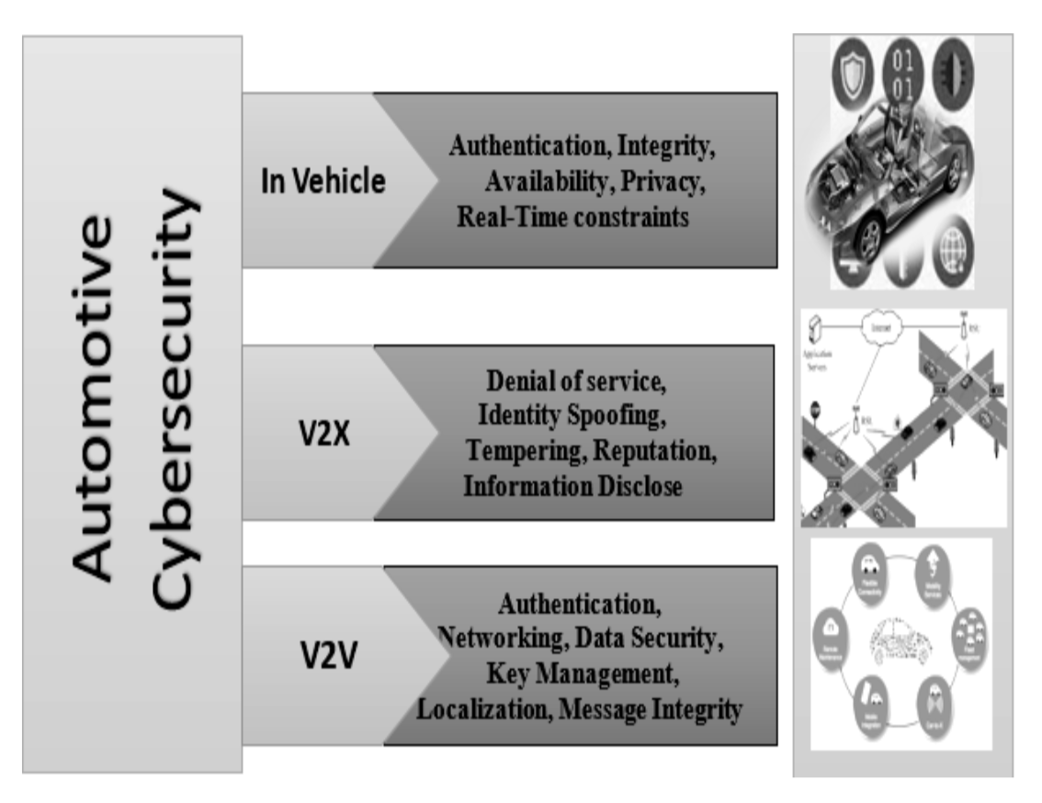

**Fig. 11: Security issues in three vehicle communication models [20].**

The possible cyber-attacks a smart vehicle may face can be classified as follows:

1. Malware Injection:

Malware is the Malicious software where a small computer code is injected into the vehicles to steal the information. Injection can be done before purchasing too.

1. Phishing Attacks:

Attackers can send an email which contains malicious files. They will be sending as disguise as known person and this will tempt the user to open the email. In smart vehicles, attackers can send emails which contain direct links that connect to vehicle’s Wi-Fi features and take control over it.

1. Denial of Service Attacks:

An attacker floods the system with more traffic, which will make it crash and make it temporarily unavailable from the outside world. An attacker might send a message “Accident near by” to the vehicle and he can repeatedly send the same message and makes the vehicle node busy and it will completely be denied for accessing the network.

1. Man, in the Middle Attacks:

The attacker can use passive sniffing to catch the unencrypted data while the data is communicated from the vehicle to outside which will enable to perform Man in the Middle Attacks.

1. Credential Reuse:

Attackers can gain the credentials and can use with any other websites. Usually, people tend to keep same credentials for different websites.

1. Attackers might steal the car or gain unauthorized access to critical systems of the vehicle. Also, they might directly affect the sensors (blinding camera sensors, spoofing signals etc.) [19]

To be protected, security must be provided for every possible sensor in the car. Provide security in between ECU’s and there must be a secured communication using any routing protocol with other vehicles or the infrastructure [20]. The most attackable ECUs are shown in the Figure 12. This tells us that as the vehicles expose to different complex attack surface, they are prone to cyber-attacks. Encryption is one way to keep all communication secure. Intrusion detection system can be useful to detect attacks in prior by observing the data streams of the connected car [19].

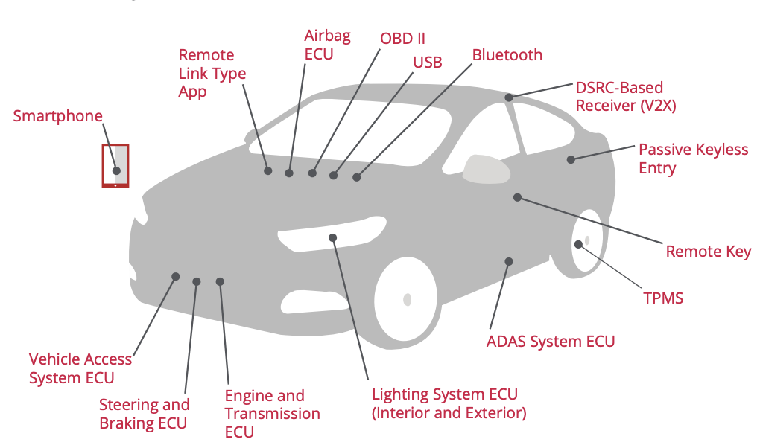

**Fig. 12: The most hackable attack surfaces [21].**

Authentication can be done in smart vehicles in the following ways [19]:

* Public-Private Key Infrastructure
* Trusted platform modules
* Open AUTH 2.0 authentication
* Pre-shared keys with a challenge-response protocol and symmetric encryption

### Data Protection

VANETS is defined as a vehicular ad-hoc network which is the most trending in the current world for communication. Digital communications between car/trucks or vehicle(s) and roadside infrastructure is established with the help of VANETS. Using the this network the following can be established:

1. Inter Vehicle Communication.
2. Vehicle to Roadside Communication.
3. Inter Roadside Communication.

Inter Vehicle Communication: Communication can be established between two or more nearby vehicles which are moving at a great speed. This can also be treated as V2V Communication.

Vehicle to Roadside Communication: Communication can be established between the vehicle(s) with the nearby roadside entities like Traffic lights, Street lights and Smart Buildings etc.

Inter Roadside Communication: It is also possible to establish communication between the two or more road side entities like Traffic lights and Network Base Stations or Smart Building and Traffic lights etc.

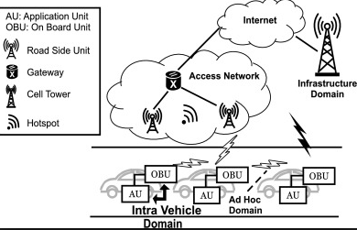.

**Fig. 13: Communication using VANETS [28].**

So, this increase the scope for an intruder or group of unauthorized parties for getting access to the information which is being stored in the vehicle(s) or Road Side entities. Hence it is very important and challenging to maintain security and privacy for the information or data stores in the smart devices.

According to research conducted by *Alberto Trombetta* et. al [27], stated that use of Identity Based Security scheme is the most suitable and better way of maintaining security for the data in VANETS.

Identity Based Security scheme is a way to control the access to a digital entity or a process of authenticating user(s) based in the his/her identity. This scheme helps in giving access for user(s) for various digital services offered or consumed by a Smart Vehicle with the other IoT devices on a network by using the user(s) specific access rights, by guaranteeing the precise match of the identity of user(s).

This idea incorporates by considering user(s) identity which is treated as an additional layer which is placed on top of the Vehicular network protocol stack. Moreover, this scheme enables to combine the user(s) identity as a security aspect for authentication.

### System Reliability and Fault Recovery

For the safety and security, networks have to be stable and provide a reliable communication in between the vehicles. Improvements in the communication protocols will enable applications on ubiquitous sensor networks. Smart vehicles which are a part of Internet of things can contain billions of heterogeneous data and various software, middleware and hardware. Network management is responsible to address many challenges which includes security and reliability.

The number of sensors is increasing rapidly and need of faster processing speed is also increasing. The decision taking and responding accordingly must happen in lightning speed. This makes sense that the need for reliable data exchange is important in vehicle to vehicle, vehicle to infrastructure and in-vehicle communication. Figure 14 shows how the system reliability concern is increasing with the trending technologies. We can see that this era of Internet of Vehicles increases in the need of network and system reliability.

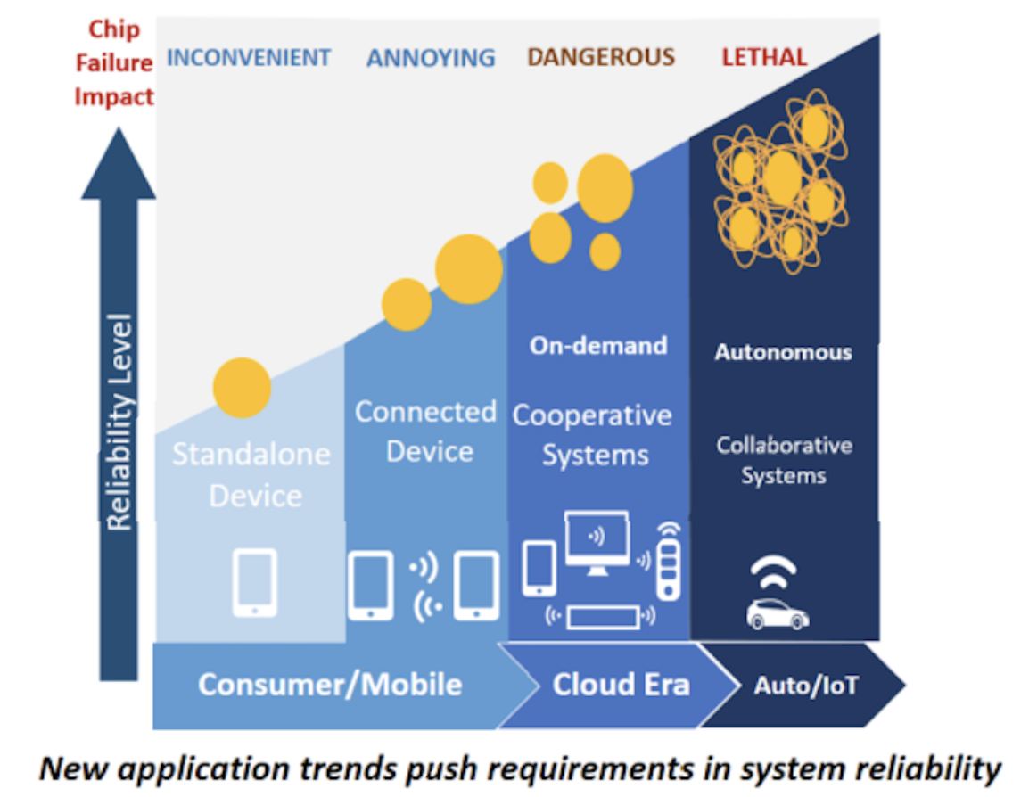

**Fig. 14: Evolving Reliability Needs [44].**

Li Yong et al [25] mentions there are three different parameters to measure the overall reliability in Internet of things. We can infer this to smart vehicles. Perception reliability involves reliability of data acquisition and short distance data transmission, transmission reliability (requirement of long-distance data transmission) and processing reliability in the application layer are the three types. Perception scope, equipment reliability, received packet rate, perception accuracy, end to end delay are the factors considered in perception reliability. Network connection reliability, end to end reliability, network throughput, safety performance is related to transmission reliability. Fault tolerance, data processing speed act as factors in processing reliability.

Smart Vehicles are very well connected, run semi-autonomously today and communicate with the infrastructure and other vehicles in the vehicular network provided by a robust technology which we know as VANETs. VANET tries to provide connectivity to the Smart Vehicles so that they are always connected, and data is always available. VANET specially focuses on the solving the biggest challenge in Smart Vehicles i.e. Mobility and Availability. DSRC (Dedicated Short Range Communication) [24] is a wireless protocol used by VANET applications based on IEEE 802.11a Physical Layer and the IEEE 802.11 MAC layer. It is a protocol designed to achieve maximized reliability. This provides a wireless link between Roadside Equipment and On-Board equipment. It supports low latency Vehicle to Vehicle and Vehicle to Infrastructure communications. This protocol is designed so that the drivers can travel more safely. Vehicles are highly mobile and therefore time management is highly important. Time is a critical component in the vehicular communication and if there is any mismatch, then failure happens.

Faults are unavoidable in such a critical communication. Thus, it is important that the system can diagnose faults and be fault tolerant. There are many technologies which make the vehicular system robust against faults and better reliable. Smart Vehicles are being focused to be intelligent and there are technologies of Artificial Intelligence and Data analytics which have made possible that without human interaction the vehicles can be autonomous. Faults can be hardware and software and researches are going on in the field of how to have robust and fast recovery in case of failures in the Smart Vehicles. RQ2 focuses on network faults and provides solutions for fault recovery in case of connectivity or network loss. This part will focus on providing answer to RQ3 which focuses on how artificial intelligence and data analytics help in fast recovery in case of faults in Smart Vehicles. [31]

There are developments in the field of the Internet of vehicles technologies, big data techniques and artificial intelligent algorithms as well. The focus has shifted towards safety and comfort for the passengers in the vehicles while driving. Data is what drives the Smart Vehicles. There is a lot of sensing and collection of data related to the environment, driver and passenger behavior. Now this section will talk about how Artificial intelligence and Data Analytics can pave way to faster response times to faults while driving.

Data Analytics is performed on the historical data and the real time data that is being collected every millisecond. And Artificial Intelligence too relies on the safe and reliable data that is available. Today AI and Data Analytics can figure out issues in vehicle beforehand before a fault occurs. This is the capability that these 2 technologies have. With the patterns recognized, it is feasible to further work on making the vehicular system. As we keep training our data models, vehicular system becomes more intelligent. Big data concept to facilitates driving behavior analysis of the drivers. With the help of the driver's background, his driving habits and the environment sensing at real time lets the system predict the possibility of the accident occurrences. Using these prediction, real time directions and assistance can be provided to the driver to avoid accidents. In full-autonomous vehicles, it may be possible the artificial intelligent system takes the full control from the driver and operate the vehicle depending on the scenario at real time. The various parameters collected from the driver's background and driving habits, the statistical model is trained on the various scenarios that the accidents can occur. This is all helpful because of the real-time monitoring in the system.

Machine learning is one of the most commonly used techniques to predict future failures by training the model against data of the possible failures that can occur. Typically, machine learning techniques includes an artificial neural network, Gaussian process regression model, vector machine. The paper [6] shows that the architecture that they built using real time big data analytics platform and intelligent machine learning components, can successfully predict the fault in the system depending on the machine/vehicle data, driving historical data and real time monitoring. This way the driver and the vehicle are assisted on how avid the fault or error to happen. This is what data analytics and artificial intelligence does- Fault Diagnosis and Fault Tolerance. What if the error/failure occurs? Can Artificial Intelligence and Data Analytics still be beneficial?

The paper [31] is where they present a fault recovery component to be a part of the Smart City architecture. Practical experiments were performed to check the fault recovery times and they proved to be quite fast. The main functionality that has been focused on here is the concept of incremental learning. The data model should be trained for the various faults as when they occur and the system itself should learn and be able to solve it better next time. There are no defined set of rules and strategies as in what should be done after and during the event of failure. The incremental learning systems make use of machine learning algorithms and the real time incoming data from the sensors to make decisions and aims at making the system operable and put the vehicle in the safe and stable state again. The structure is given in the below Figure 15 presenting Failure Recovery component. In case of the event of failure, the system recognizes the last stable state and tries to figure out the estimate the value and keeps the system operational.

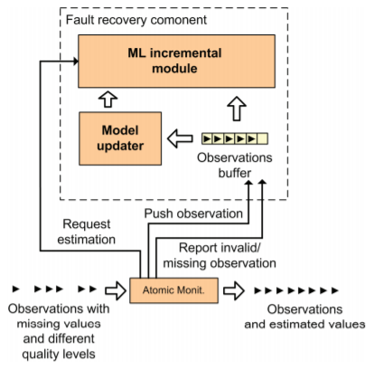

**Fig 15: Fault Recovery Machine Learning Component [31].**

The graph shows the recovery response times which look very impressive for IKNN model. But how do they react, what steps AI and Data analytics provide for safety and comfort of the passengers in the vehicle.

**Graph 1: Shows the machine learning algorithm response times in failure recovery [31]**

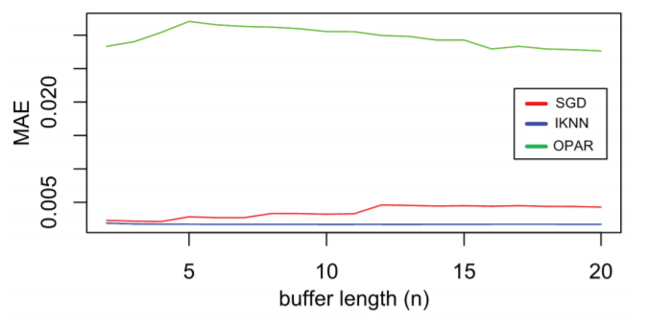

We know that Artificial Intelligence is what makes machines smarter and give them the ability to think. But this is a very critical task on if there is a fault then how should the vehicle behave. There are no rules of thumb to be followed as of now. In high end cars, the ADAS (Advanced Driver Assistance System) helps to detect the hazards that can occur on the road. It provides the driver with the guidance and steps on what should be done but this is before the failure has occurred. It also predicts if the vehicle collision is about to occur and thus the driver can be alerted with alarms and voices and feedback that the failure scenario might occur.

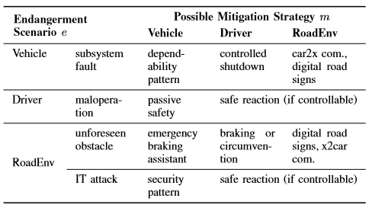

**Fig. 16: Possible mitigation strategies [33].**

Multiple projects are already being worked upon in the research areas of AI and machine learning to have a verified result. There are certain criteria to be looked upon as per [32] to find out how the vehicle should behave in case of failure and how to recover from that failure. One approach that this paper discusses is to have a combined verification technique including design time and run time verification. They still focus on learning based Cyber Physical systems. That means with time and better valid data fed to build the recovery model, the system will self-learn and understand how to behave in case of failure recovery. Artificial Intelligence and machine learning algorithms will make it possible and will be responsible for responding with a solution for the fastest recovery in no time.

There is a need to outline a model for controllers that can help mitigate the effects of the failure that has happened. It must be capable of run-time failure identification and mitigation. The paper works on identifying a few cases and try to define variables to be considered to identify the hazard and the strategies that need to be formed to help diminish the effect. They define the following two cases:

1. Identify failure causal factors and what scenarios it results into

2. Derive operational strategies for diminishing the scenarios.

The approach provided in the paper is a fail-safe control strategy as well as the application of these strategies to a control system vehicle.

Smart Monitoring captures and generates sensed data and the Big Data provides the platform for handling huge amount of data. It is believed that 25GB data is created in one hour by the vehicle. Data analytics is what is required as it helps convert the mathematical codes to real understandable values. By monitoring dozens of sensors, Data Analytics can help monitor all kinds of performances of the smart vehicles and make run time notifications to the driver regarding what is wrong may be speed limit, may be temperature rise in the car. Analytics that can drill down [to the pixel level](https://healthitanalytics.com/news/googles-machine-learning-imaging-analytics-flag-breast-cancer) on extremely large digital images can allow providers to identify nuances that may escape the human eye.

AI is the one which helps figure out the anomalies and self learns and provides better decisions which can identify dangerous situations. It can then alert the driver and these days take control of the vehicle from the driver in emergency cases in order to avoid an accident because AI is very quick. AI monitors a lot of sensors at the same time and can detect problems before fault occurs in the vehicle. Emergency braking, cross traffic detecting, blind spot monitoring, and driver-assist steering can help avoid accidents and thus save lives. One of the most important aspects of AI in automotive is the constant learning and adjusting rules. Each vehicle makes the information it learns available to the rest of the fleet. The result is a virtual neural network of self-driving vehicles that learn as they go. all that data is fed into an AI program that turns sensory data into vehicle control data. AI has the capability to figure out very small changes. So, another feature that AI gives computing is to offer predictive maintenance. AI has the power to what the driver wants. IT is close to a human brain. Human brains can take time and therefore we have AI which can figure out the correct solution on its own and that is why we call it intelligent. In case of get drunk, AI can take you back home. It can take your place if you sleep. It can take you to the right most lane and make a stop in case of flat tire. IT can start all sorts of preventive and safety measures to be on in the vehicle as per the weather scenarios. It can move the rain window wipes for you so that u is not distracted and on the right speed as per the rain analysis. It predicts if accident can take place or not. In 2017, there were an estimated 40,000 traffic fatalities in the U.S., with more than 90 percent of them caused by human error, according to the National Safety Council.

They don’t text and drive, or drive under the influence of alcohol, or drive too fast, which makes them much safer than humans.

Predictive analytics is being used in electric grid and reinforced machine learning algorithms are being used providing very good results in finding error with very high response times. There seems to be a fact saying that a car can learn driving in 15-20 ins using reinforcement learning. So, fault recovery will be faster. Therefore, I believe deep learning, generative networks, reinforced learning and convolutional networks. will help to make the machine learn better and in a faster way with very low latency and in real time. I also believe we apply these rules and strategies using AI and Data Analytics, identification of failure will be faster, and the self-learning system will be able to respond faster for the recovery.

### Child Safety and Comfort

Safety and comfort for baby in the cars is an important part to look at while we are dealing with the safety of the smart vehicles. As babies are small and they cannot express their needs and discomforts, it is good idea to realize their discomforts and act accordingly. When babies are in the car, we must drive more cautiously to avoid any accidents. When smart and intelligent systems take care of our safety and our family safety, that would be a great blessing.

The smart monitoring system used in the paper [29] is the existing system which tracks the behavior of the driver and informs the driver if any parameters in the car monitoring system are going wrong. It also informs the police nearby if there is any violation of the laws. The smart vehicle system has three main parts that is black box, eye blink sensor and seatbelt-controlled ignition system. The vehicle will have different sensors and the sensors monitor different parts. Vehicle black box will store all the data sent out from the sensors which calculates various performance of the vehicle. Seat belt sensor detects whether the seat belt is clipped or not, temperature sensor senses the temperature of the vehicle and eye blink sensor will detect the eye blink of the driver. Alarm and LCD are the output of the system. Alarm will sound when the driver sleeps and LCD display messages. Arduino Mega 2560 is a microcontroller board and it is the main part of the system. Arduino is a smart tool which senses and control over the physical world. It is the open source physical computing platform which works based on the design of the microcontroller board.

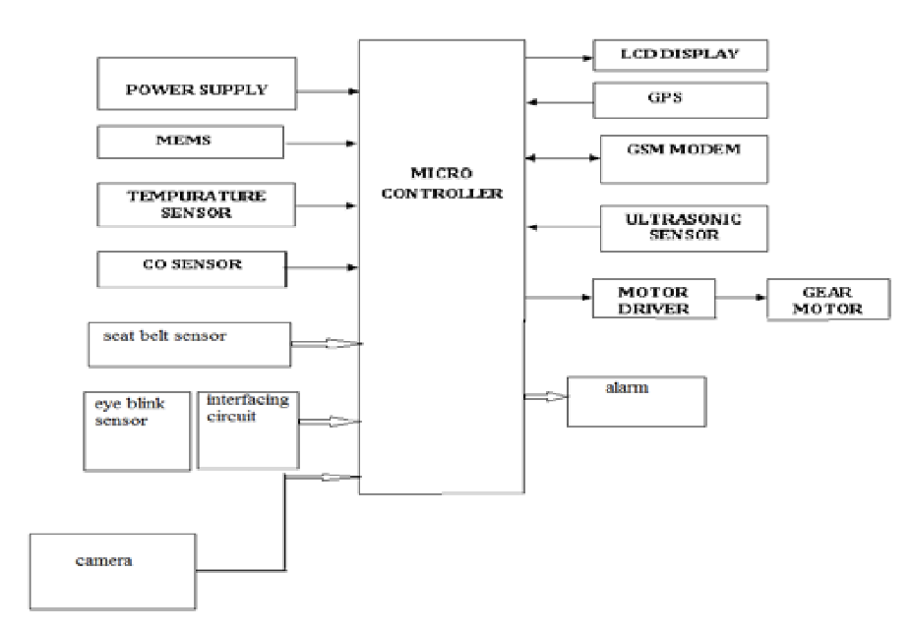

**Fig 17: Smart vehicle system having microcontroller and other sensors as input, LCD display and alarm as primary outputs [29].**

Seat belt-controlled ignition system uses a hall effect sensor which is placed on the clipping part of the seat belt. Seat belt tongue of the passenger car seat is magnetized and when the tongue places near to the sensor, sensor assumes that the seat belt is clipped, and it generates an output to the microcontroller as a pulse. In LCD display, a warning is shown that the seat belt is not clipped. Vehicle accident prevention using eye blink sensor: An eye blink sensor is placed near the eyes to sense the eye blink count and this data is sent to the microcontroller black box as pulses. Microcontroller checks with the already existing normal eye blink and if there is any abnormality, then the output is given as an alarm sound. Several automobile manufacturers have used these concepts to monitor driver’s behavior by placing eye blink monitor which helps to produce a sound which will help the driver to be alert. Vinoth et.al [30] have given a design for the car seat which can avoid deaths and injuries when the children or the physically challenged persons are left in the car unattended. They say that tinted windows and circulation fans would not be enough if the temperature of the surroundings is peak. If there is prolonged exposure of high temperatures, it may affect the babies left alone in the cars. They proposed thermoelectric coolant system where it can maintain the body temperature for some time. A thermistor and a seat occupant system will detect an unsafe rise in temperature and activates the cooling systems. To achieve the cooling range, they have used single TEC (Thermo Electric Coolant) with DC power supply. PIR and LM35 sensors are placed under the child seat. PIR for occupancy or vacancy detection and LM35 is a temperature sensor. We can use this idea to achieve safety of the babies or the physically challenged people left in the parked cars. This helps to avoid any fatal incidents by using a coolant system which can maintain the cabin air temperature for two hours.

Considering the above work of the researchers related to passenger safety, I would like to propose two solutions for safety and comfort of the baby in the vehicles.

From the time the baby boards the car, we should make sure the baby is comfort and secured until the baby gets down. There are few factors where the baby feels discomfort. The baby in the car may feel discomfort for few reasons like the temperature in the car becomes too cold or too hot, when baby is hungry, and when there is a need to change diaper. Driving must be not disturbed just because the baby being cranky and crying for any reasons.

My first solution is that the car is equipped with few sensors near the baby to keep the baby monitored and for driver to drive safe to keep the baby comfort and secured. There will be a small LED monitor before the driver which can inform the baby comfort level and any sort of messages. Baby will have a tablet like monitor which acts as an interactive device, temperature sensor and consists of a camera. All this sensed data is sent to a microcontroller and this will give output as messages to the LED monitor. Along with that if the baby car seat is smart enough such that it is made up of a thermo coolant system, heart rate monitor, pee and poop sensor and seat belt sensor, then it is easy to monitor baby always while driving and keep the baby comfort.

The following are the different usages:

* Seat belt sensor detects if the seat belt is not clicked properly or if the child is trying to remove the seat belt. This will send as a pulse to microcontroller and microcontroller will give the output as “Seat belt” in the driver monitor.
* With the temperature sensor, we can check the temperature around the baby with the minimum and maximum temperature levels a baby can be comfort. If that doesn’t match with the criteria, we can inform the driver by displaying a message to driver to reduce the AC temperature or to increase the temperature in the car.
* We can use humidity check sensor and gas sensor as very small device. We can write the code for the sensor to check if the humidity is more, then inform in the driver monitor that “Baby diaper is full” and if there is gas detected, then a message saying “Baby pooped” displays when the microcontroller gives output to the LED monitor of the driver.
* Instead of the eye blink sensors to detect whether the driver is sleepy or not, if we place a sensor monitor to the car seat which can detect heart rate and breathing, this can check with the sleeping patterns of someone who is sleeping. If this match, it can generate a message in the driver monitor and can ask if the driver is ok to redirect to nearest coffee shop or nearest parking place to have a short nap. Many studies have shown that after 20 minutes of a short nap, the alertness of the driver increases. In this way, we can predict the drowsiness of the driver in beforehand, which can even avoid accidents before itself.
* RPM (Rotations per minute) sensors convert mechanical motion to electric pulses when they are placed in direct contact or nearby to the rotor, gear, shift. The measured RPM can then be converted to miles/hour. If the vehicle speed is monitored in this way, any increase in the speed than the threshold will send the data to the monitoring system of the driver and it displays to the driver as a speed warning as “BABY ON BOARD, GO SLOW!”
* The heart rate monitor attached to seat belt of the child tracks the baby all the time (whether driving or in parking). Any heat stroke or abnormality in breathing can be easily sensed and gives a message to the parent that the child is at risk.
* An alert comes to parent’s mobile after few seconds if the baby is left in the car seat and parent locks the door and the microcontroller checks when the door is closed, then the baby in the car seat is present or not. If yes, then the safety alert goes to the parent

Leaving the baby in the car is unlawful. For suppose, if the parent leaves baby in the parked vehicle, then the thermo coolant system that we are using for the car seat will be useful to keep the baby safe. Sometimes network might go down and mobile networks might fail to send or receive messages. Even at that point of time, I would like to make sure that my proposed idea will work to keep baby safe. As mentioned above, the monitoring device installed before the baby car seat will have a monitoring camera and a temperature sensor which also helps to monitor child’s status when they are left out in the car. The device also acts as an entertainment media to keep babies engaged. Whenever we leave the baby in the parked vehicle, we can monitor her from the mobile phone and observe what he/she is doing and when the temperature is raising because of the surroundings, an immediate alert comes to the parent mobile that the temperature in the car is increasing and the thermo coolant is on and sends a message “Not to worry”. If time progresses and the parent does not return, that is if the threshold time exceeds, the smart device monitor will automatically open the windows and make an alarm saying, “Baby here, Call 911”. This alarm will alert the people nearby and save baby.

The other solution can be using the Artificial Intelligence and Big Data analytics and even BCI (Brain Computer Interaction), we can achieve safety and comfort features for the driver and the baby in the car. I would like to explain this solution in the following section about Future Trends.

### Future Trends

There would be two types of cars in coming future. They are driver assist and driverless automobiles. Driver assist has a personal driver assistant system. When the driver is tired, as it monitors, using AI, the personal assistant systems would ask to take rest and suggests that there is a coffee shop nearby and would you like to drive me there! When travelling with baby, drivers must be more cautious. AI would assist the driver and makes him be alert while driving to provide safety to the passengers and babies if they are in car. Personal assistant can talk to you and can connect to internet whatever you like. AI and Data Analytics play a major role to improve the technologies. Personal assistant in the vehicle would assist in connecting to other vehicles nearby and see that if there is a drowsy driver nearby, it alerts you to change lane. This way, precautions are taken before facing any type of accidents. Driver assistance systems would also suggest if the baby in the car is feeling discomfort because of any reason. It can sense the sensed data and act accordingly. It can take over the control of changing temperature in the car when baby is feeling cold or hot, it can switch on the AC when parents leave the baby in the car by mistake or wantedly for some time. It could help to entertain baby by playing his/her favorite songs. When we are going through any of your relatives’ homes, it may suggest you if you want your baby to take to their home. Sometimes, when the driver could not take a decision to stop if there is an objection before the vehicle, personal assistant systems will help to take over the control and provide braking. If there are any child abduction places, using AI and data analytics, the personal assistant systems will suggest you not to park the car in such places and make sure you are not leaving baby or children alone here if you are parking. These all can use AI cloud services.

In autonomous vehicles, there is a concept that can happen in future. As of now, we have both driverless and driver assistant cars which are utilizing Artificial Intelligence and Human Computer Interaction. Brain Computer Interaction [39] is one technology which can be used in autonomous vehicles where there will be high level of interactivity with the occupants in the cars. BCI can provide continuous access to each passengers’ music, movies preferences. They investigate passenger comfort. The complete autonomous car could become a mini lounge and we can design interior as our wish. The car can become as a home theatre and can be used to see users’ favorite movies in the BCI interfaces. Imagining car becoming a hotel room looks good in the future. Related to children safety, parents can sit with their babies aside and can take care of them. With the sensed data, BCI will suggest when to change diaper of the baby, when to feed them and so on, even if the parent forgets. The technology can become a caretaker. When parents leave the baby or the children in the car, BCI helps to interact with the child and it basically knows what they love and play the videos. If BCI develops in the same pace as of now, we can imagine cars without any physical interface. All the data can be fed into person’s visual or auditory consciousness. In the same way, intention of the users can be known automatically which can detect your opinions and will make physical input not necessary. Using techniques like neural decoding and recalibration, cars will be able to monitor neural patterns of the car user and take them to their desired location, play music in their mind. Car speed, engine problems etc. can be fed to the users using visual and auditory augmentation. According to Ashraf Gaffar et.al [39], medical prosthesis devices will be used for visual and auditory augmentation. The authors are also assuming that cochlear implants might be the main technology which can be used for audial augmentation

There might be also cars where emissions would be pure oxygen. May be after 3 decades, we can see such cars. This can be the technology that comes from Mercedes Biome.

### Case Studies, Examples, and Analysis

***Case Study 1 [38]: Finding parking slot for a Smart Vehicle in a Smart City.***

A wait period of 5-10 mins for haunting down a parking space for a vehicle on a regular basis means that, each year it would take approximately 30-60 waiting hours for a user or a driver to find a parking space to rest the car. This will lead to discomforts for the driver and passengers travelling in the vehicle to find a parking spot.

This wait period may also increase in densely populated cities such as Westminster and Montpellier, which are metropolitan cities located in London and France respectively. As the wait time increases for searching a parking slot around the city for newly visiting people unnecessarily increases the usage fuel or electric charge of the vehicle and if the vehicles run on the fuel, it would increase the level of smoke pollution.

The two cities mentioned above are considered as one the Smartest and well-developed cities which have excelled in building and implementing various newly trending applications of IoT which mainly focus on the mobility of the Smart Vehicles.

Westminster city is considered as the heart of London and every day it has an inlet of around 100-300 vehicles for every 15 minutes during its peak hours and weekends. Due to the increase in the number of vehicles coming into the city, many traffic congestion problems arise, and it has become challenging task for the people to find a parking spot for their vehicle. So, the officials and researchers have worked on this challenging task and finally came up with a solution by using the concept of Smart Cars and Smart Parking in their Smart city.

They have introduced a new IoT device which helps to detect the presence of the car in the parking slot and communicates with this information with other IoT devices which are present in the Smart city. This communication between the heterogeneous IoT devices takes place among various hardware and physical entities like Traffic Lights, Roadside Infrastructure and many more.

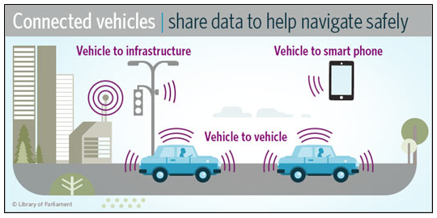

**Fig. 18: VANETS (V2V, V2I and V2M Communication) [39].**

So here in this case, use of VANETS may also help in effective communication between the IoT Parking device and Smart Vehicles. The use of Vehicle to Vehicle (V2V) communication or Vehicle to Infrastructure (V2I) communication could enhance the rate of communication using the 5G network.

***Case Study 2: Rerouting of Smart Vehicle to avoid traffic problems in harsh weather conditions like heavy snowfall or rainfall.***

Basically, we may users or drivers fear to travel long distance during harsh winter conditions in their car. It is because of various reasons of safety and comfortness of the people and driver who is travelling in the car. It some situations, people believe that due to heavy snowfall or an accident that may take place which may sometimes lead to traffic congestion which can’t be predicted prior the start of their journey.

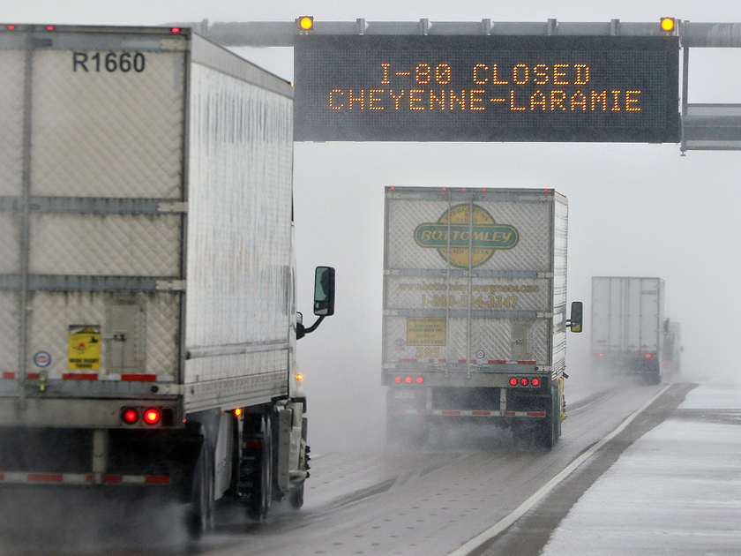

**Fig. 19: Road closed due to bad weather conditions [42].**

The following Fig. 20 shows some statistical information regarding the accidents that took place during a span of 10 years due to various weather conditions in United States of America.

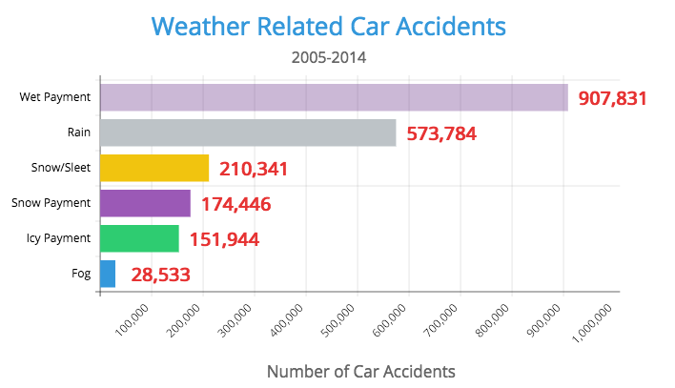

**Fig. 20: Car accidents took place in a span of 10 years from 2005-2014 in US [43].**

So, with the help of integration of Vehicular Ad-hoc Networks (VANETS) for the communication in the Smart Vehicles, we can establish the following communication networks:

1. Vehicle to Vehicle to Communication.
2. Vehicle to Infrastructure Communication.
3. Dedicated Short Range Communication.

So, with the help of these technologies combined with Big Data Analytics and Artificial intelligence into the Smart Vehicles, we can predict the current weather situation between the source and the destination of the user or passengers. We can also predict and measure the number of Smart Vehicles present in a location per unit area and can reroute the vehicle if there is possibility that a traffic congestion is going to occur during the travel.

***Case study 3: Child Safety in Parked Vehicles***

According to statistics reported by CNN, they say that more than 36 children die every year in hot cars because of hyperthermia as a result of being left unattended. Hyperthermia is a condition when the body must accept more heat than it can accepts. It mostly affects children because their body temperature can easily increase 3 to 4 times faster than the adults because of less water reserves. It is said that the temperature in the parked vehicle can increase by 10 to 15 degrees within 15 minutes. Figure 21. shows the number of children die each year from 1998. It is also reported that such incidents happen usually in the peak summer. Statistics show that child deaths around 55% happen mostly among the children between 1 to 3 years of age, 32% less than one year and 13% greater than 3 years. It is indeed a very necessary measure to look after the child safety in the vehicles. The reasons behind leaving the children in the car seats also vary. Mostly, people have forgotten their children in the car and locked. Figure 22 shows the different circumstances of leaving children in the car. This shows that there is a need to improve safety precautions to save babies from heat strokes.

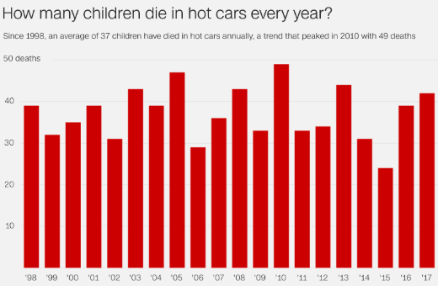

**Fig. 21: Statistics of child deaths in hot cars [41].**

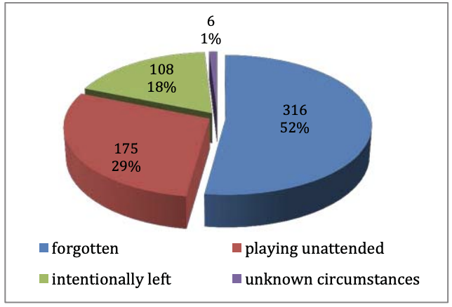

**Fig. 22: Circumstances to leave children in parked vehicles [40].**

From the proposed solutions to provide safety for the babies in the car, we can use them to avoid accidents caused by the heat strokes. Firstly, if the baby is left in the car seat and parent locks the door, that may be by mistake or in forgotten case, an immediate alert come to mobile that baby is left out in the car. Second, if the baby is left in the car wantedly, then my proposed monitoring system will help to monitor the child from the mobile phone as it has a camera. When temperature increases, then the monitoring system will inform the parent that the thermo coolant is automatically on. Even after some time, if the monitoring system acknowledges that the parent does not return or when the network is down, and messages are not reaching to parent, then the car windows are down and then an alarm sounds “Help!!, baby is here, Call 911”. With the second solution, using the Artificial Intelligence, driving assistant system warns you if the baby is left out in the car unwantedly. Although if it’s unlawful to leave baby in the car, some ignore and leave the children hoping they would return soon. At that time, driving assistant system will make sure the baby is in comfort zone, AC is on always and the temperature is not raising. After some time, when the parent does not return, driving assistant system calls 911 and makes sure baby is in safe and comfort zone.

***Analysis:***

So, with the help of emerging technologies like 5G, VANETS and Sensing techniques, we can make Smart Vehicle work effectively in the real world. With the emergence of Smart City which is basically a combination of both Smart City and Smart Infrastructure, implementation of the Smart Vehicles be done very quickly and easily. Effective and fast communication between the Smart City and Smart Infrastructure make the Smart Vehicle to work in a better way which leads to the comfortness and increases the safety of all the passengers travelling in the Smart Car. 5G network availability is not far. Looking into the architecture of having Real time data processing and data fed to Artificial Neural Network algorithms for quick identification of faults before they occur is very powerful. With these technologies, we will be able to quickly respond in case of dangerous failures as there will be faster response with very low jitters and latency. Artificial Network system is self-learning and can make decisions for multiple situations for humans. And with 5G networks, the response will even be higher. Implementation of a robust architecture like AVC will be very beneficial, easier to implement, test and deploy. Not only this, the AVC components provide modularity to the whole system. Data Analytics can help provide data regarding what issues happened and the root cause for it. Also provide solutions and next steps to be taken to fix it. Failure recovery and failure tolerance will help provide high levels of comfort and safety for the passengers.

With the trending technologies, the comfort and safety of the passengers can be increased. Especially with child safety, many accidents caused by heat strokes in the car can be avoided. Artificial Intelligence, Human Computer Interaction which are the present trend in technologies which can improve the safety of the babies by informing parents of the forgotten child in the car, it would remind parents about the baby feeding and diaper change routines. Any discomforts caused due to temperature change in the car can be automatically adjusted according to the sensed data to keep the baby comfort in the car. Before the human reacts to any dangerous situation, present technologies could foresee before and warn the driver in before to achieve the safety of the passengers. With Brain Computer Interaction which can be a new technology that will be introduced in the automobiles in coming future. Parents can be with their children when it is an autonomous car. They can directly take care of the baby. We can design the car according to our own desire. BCI can provide safety and comfort for each passenger individually. Its main aim is to improve the interactivity among the passengers with the cars.

### Project Steps

This project is a combined report of the a few major topics we investigated:

1. Internet of things, networking and 5G.
2. Mobile Edge and Ubiquitous Computing in Vehicles making the concept of Internet of Vehicles and Connected Vehicles real.
3. Safety and Comfort and Special Case has been studied for safety of children in the vehicles.
4. Discussion on if there is communication loss of the vehicles with the infrastructure, how do we stay connected and still get correct updates.
5. Fault Tolerance and Fault Recovery using Artificial Intelligence and Data Analytics and how the machines become intelligent by learning themselves.

To actively stay involved with everyone in the group and try to clarify multiple issues we faced, we followed the following steps:

1. Tried to search existing issues in the research areas.
2. Consistently tried to read about different researches available in multiple journals including IEEE papers and online materials and Google Scholar.
3. We discussed our ideas with each other trying to check if we are on correct path to find the solution.
4. We created a fixed schedule for meeting at least 2 times in a week for going over the upcoming week’s agenda.
5. We created a Google Doc Project file template as to stay on the same page regarding the paper documentation and, we to have a continuous discussion of our topics by reading each other’s work.
6. We also put our ideas we came up with and questions regarding any issues we faced with our professor mentoring us in this project.

### Phases and Efforts

Following table gives the data about the time timeline and topics covered every week showing the phases and efforts made by all the members of the project.

|  |  |  |  |  |
| --- | --- | --- | --- | --- |
| **Date** | **Work to Do** | **Start Date - End Date** | **Assign To** | **Team Meetings**  **Date & Time** |
| Week 1  10/12/2018 | Write abstract,  come up with 4-5 papers research questions, a brief project plan and write a rough draft of the abstract for the project. | 10/12-10/22 | Anusha, Sampath, Aakanksha    Abstract,  Project Plan  Research Questions | 10/16[2:30PM-4:30PM]  10/17[2:30PM-3:30PM]  10/19[10:00AM-12:00PM] |
| Week 2  10/23/2018 | Mobility, Wireless communication  Data Collection, Transport, Processing Introduction, Key Features, Phases, Highlights - | 10/23-10/30 | Anusha- Mobility, Wireless communication  Sampath- Data Collection, Transport, Processing Aakanksha-Introduction, Key Features, Phases, Highlights - | 10/23[2:30PM-3:30PM]  10/24[2:30PM-3:30PM]  10/26[10:00AM-12:00PM] |
| Week 3  10/30/2018 | Mobile Edge computing  Future Trends  Open issues | 10/30-11/5 | Anusha- Mobile Edge computing  Sampath- Future Trends  Aakanksha- Open issues | 10/30[2:30PM-3:30PM]  10/31[2:30PM-3:30PM]  11/2[10:00AM-12:00PM] |
| Week 4  11/6/2018 | Reliability and Performance Network and System Reliability Network and Data Protection | 11/6-11/12 | Anusha- Reliability and Performance  Sampath- Network and System Reliability  Aakanksha – Network and Data Protection | 11/6[2:30PM-3:30PM]  11/7[2:30PM-3:30PM]  11/9[10:00AM-12:00PM] |
| Week 5  11/13/2018 | Work on Research Questions and finding solutions  Where to use encryption  Trade off Potentials  Performance Issues | 11/13-11/19 | Anusha- Where to use encryption  Sampath- Trade off Potentials  Aakanksha –  Performance Issues | 11/13[2:30PM-3:30PM]  11/14[2:30PM-3:30PM]  11/16[10:00AM-12:00PM] |
| Week 6  11/20/2018 | Work on Case studies and examples related to the Smart Vehicles and research methods related to the Research Questions. | 11/20-11/26 | Anusha–Case Study1  Sampath–Case Study2  Aakanksha-Case Study3  All with examples | 11/20[2:30PM-3:30PM]  11/21[2:30PM-3:30PM]  11/23[10:00AM-12:00PM] |
| Week 7  11/20/2018 | Work on Case studies and examples related to the Smart Vehicles and research methods related to the Research Questions. | 11/27-12/3 | Anusha–Case Study1  Sampath–Case Study2  Aakanksha-Case Study3  All with examples | 11/20[2:30PM-3:30PM]  11/21[2:30PM-3:30PM]  11/23[10:00AM-12:00PM] |
| Week 8  12/4/2018 | Final Report Submission and Presentation | 12/4-12/10 | Anusha –Project Steps, Project Strengths  Sampath – Project Efforts, Project Limitations  Aakanksha – Research Methods, Lessons Learnt | 12/4[2:30PM-3:30PM]  12/6[2:30PM-3:30PM]  12/8[10:00AM-12:00PM] |
| Week 9  12/11/2018 | Final Report Submission and Presentation | 12/11-12/14 | Anusha – Results & Analysis  Sampath – Future Work  Aakanksha - Conclusions | 12/11[2:30PM-3:30PM]  12/12[2:30PM-3:30PM]  12/13[10:00AM-12:00PM] |

### Research Methods used by the Project

We started with Literature Review for each of the research questions that we are trying to answer in the paper. A lot of research papers were read to figure out relevant papers to our research questions. Further we did critical analysis of the literature, we started looking into various issues and examples related to our work which we could use. We try to imagine the issues and provide our own imaginative answers to the research questions. We investigated the latest available technologies for solutions as well. We also added case studies and examples supporting our research answers for Smart Vehicles. We also read a lot of interesting articles on various websites to get the latest statistics and gain more insight.

### Project Strengths and Limitations

*Project Strengths:*

1. The project has covered the latest issues in Smart Vehicles and focused on the main issue of safety and comfort for the occupants in the vehicles.
2. The project investigates the latest technologies to provide solutions for those major issues.
3. The project provides interesting case studies as well to represent the issues present in smart vehicles and what necessary steps can be taken to solve them.

*Project Limitations:*

1. More research in the field of safety and comfort is required especially for Fault Tolerance and Recovery because there are still a lot of issues to be solved. The machines are not fully autonomous. Fault Recovery is the main issue to be investigated to make a machine fully autonomous. This research area is still pending.
2. More Case studies and Examples could have been added to provide better insight on the current standard and status of autonomous vehicles.

### Lessons Learned

1. We struggled with how to stay in focus with the specific research area. In process of doing so we tried to learn that we should keep consulting our professor and have discussions with each other in the group to be focused on our specific questions.
2. We faced time management issues as well. But with continuous interaction we managed to complete our project. We put a lot of time in deciding how to proceed and in case we are in the right direction. We learnt to not waste time on if we are right or wrong, when we are stuck, we should consult.
3. We also learnt that reading one paper and one issue can open to more issues and we get more material and then we can narrow down. We understand our issue and research area better with more and more reading.

### Proposal for Future Work

The research we made in this project can be extended by implementing the solutions proposed in a simulated environment. For better machine learning algorithms and models can be considered for implementation of the fault recovery and tolerance in the vehicles. Better data analytics technologies can also be used for faster help in case of failures. Apache Storm can be used for real time streaming. Also, better self-learning models can be implemented based on our research for better safety and comfort mechanisms. Coming down the line, we make this approach to be implemented in the real work when the 5G network is completely released into the real world. We can also design some new algorithms which could enhance fast communication between the two or more Smart Vehicles. With the next level of VANETS and 5G, there is a possibility that a new term introduced into the market which is known as Internet of Vehicles (IoV). This innovation may lead to a situation, where each Smart Mobile Vehicle acts as an Internet Service Provider (ISP) which increases the rate of communication around the world. Baby safety and comfort can be investigated. First solution of the work using microcontroller and different sensors to track the baby and the driver can be implemented using Arduino microcontroller board and by writing code for each functionality that we require. We can have a possibility to check if they can work. Also, when 5G and autonomous cars are in action, then the safety and comfort of the babies will be drastically improved.

### Conclusions

In Smart Vehicles, a lot of investment is done in terms of money as well as time. A lot of researchers are trying to make the vehicles autonomous and multiple projects are going on around the world. Big shot vehicle manufacturers like Google, Tesla, BMW, Mercedes are working on practical implementation of a fully autonomous cars right now. As researchers we also have investigated the issue of safety for the vehicles in case of failure occurrence. Another is of research was to provide solutions related to how can we make occupants in the car more comfortable. We have safety and comfort as the main areas for research where we proposed solutions. One research concentrates on how 5G and mobile edge computing will open the world to better mobile and connected vehicles with better connectivity in case of communication failure. This is important because we should be able to communicate and get updates and answers in case, we do not have proper connectivity. We should be able to communicate with other vehicles. Many child deaths are happening, and child is the most vulnerable to uncomfortability because they cannot express their issues and uncomforted. So, it is very necessary to find solutions for providing extra safety and comfort to the children and we believe our answers can be useful indeed. With Artificial and Data Analytics with full-fledged implementations can help avoid many dangerous accidents. We consider without AI and Data Analytics we will not be able to achieve full autonomous feature in the vehicles. AI and data analytics help with monitoring, predictive analysis, real time tolerance in case of failure of components. There are suggested future work in internet of vehicles and augmented reality as well making life of occupants in the vehicles very comfortable which can be used researched more.

### References

1. J. Gubbi, R. Buyya, S. Marusic, and M. Palaniswami, “Internet of Things (IoT): A vision, architectural elements, and future directions,” *Future Generation Computer Systems*, vol. 29, no. 7, pp. 1645–1660, 2013.
2. R. W. L. Coutinho, A. Boukerche, and A. A. F. Loureiro, “Design Guidelines for Information-Centric Connected and Autonomous Vehicles,” *IEEE Communications Magazine*, vol. 56, no. 10, pp. 85–91, 2018.
3. D. Kombate and Wanglina, “The Internet of Vehicles Based on 5G Communications,” *2016 IEEE International Conference on Internet of Things (iThings) and IEEE Green Computing and Communications (GreenCom) and IEEE Cyber, Physical and Social Computing (CPSCom) and IEEE Smart Data (SmartData)*, 2016.
4. A. Gupta and R. K. Jha, “A Survey of 5G Network: Architecture and Emerging Technologies,” *IEEE Access*, vol. 3, pp. 1206–1232, 2015.
5. A. Soua and S. Tohme, “Multi-level SDN with vehicles as fog computing infrastructures: A new integrated architecture for 5G-VANETs,” *2018 21st Conference on Innovation in Clouds, Internet and Networks and Workshops (ICIN)*, 2018.
6. J. Kim, H. Hwangbo, and S. Kim, “An empirical study on real-time data analytics for connected cars: Sensor-based applications for smart cars,” International Journal of Distributed Sensor Networks, vol. 14, no. 1, p. 155014771875529, 2018.
7. K. Zaidi and M. Rajarajan, “Vehicular Internet: Security & Privacy Challenges and Opportunities,” *Future Internet*, vol. 7, no. 4, pp. 257–275, 2015.
8. I. Stojmenovic, “Fog computing: A cloud to the ground support for smart things and machine-to-machine networks,” *2014 Australasian Telecommunication Networks and Applications Conference (ATNAC)*, 2014.
9. Q. Zhu, R. Wang, Q. Chen, Y. Liu, and W. Qin, “IOT Gateway: Bridging Wireless Sensor Networks into Internet of Things,” *2010 IEEE/IFIP International Conference on Embedded and Ubiquitous Computing*, 2010.
10. K. Kai, W. Cong, and L. Tao, “Fog computing for vehicular Ad-hoc networks: paradigms, scenarios, and issues,” *The Journal of China Universities of Posts and Telecommunications*, vol. 23, no. 2, pp. 56–96, 2016.
11. A. Gharsallah, N. Omheni, K. Ghanmi, F. Zarai, and M. Neji, “A Seamless Mobility Mechanism for V2V Communications,” *2017 IEEE/ACS 14th International Conference on Computer Systems and Applications (AICCSA)*, 2017.
12. X. Xingmei, Z. Jing, and W. He, “Research on the basic characteristics, the key technologies, the network architecture and security problems of the Internet of things,” *Proceedings of 2013 3rd International Conference on Computer Science and Network Technology*, 2013.
13. D. Sinh, L.-V. Le, B.-S. P. Lin, and L.-P. Tung, “SDN/NFV — A new approach of deploying network infrastructure for IoT,” *2018 27th Wireless and Optical Communication Conference (WOCC)*, 2018.
14. M. M. Alsulami and N. Akkari, “The role of 5G wireless networks in the internet-of- things (IoT),” *2018 1st International Conference on Computer Applications & Information Security (ICCAIS)*, 2018.
15. A. Siddiqa *et al*., "Social Internet of Vehicles: Complexity, Adaptivity, Issues and Beyond," in *IEEE Access*, vol. 6, pp. 62089-62106, 2018.
16. S. K. Datta, R. P. F. Da Costa, J. Härri and C. Bonnet, "Integrating connected vehicles in Internet of Things ecosystems: Challenges and solutions," *2016 IEEE 17th International Symposium on A World of Wireless, Mobile and Multimedia Networks (WoWMoM)*, Coimbra, 2016, pp. 1-6.
17. Lu, Ning, et al. "Connected vehicles: Solutions and challenges." *IEEE internet of things journal* 1.4 (2014): 289-299.
18. Singh, Aman, and Madhusudan Singh. "An empirical study on automotive cyber attacks." *Internet of Things (WF-IoT), 2018 IEEE 4th World Forum on*. IEEE, 2018.
19. Haas, Roland E., and Dietmar PF Möller. "Automotive Connectivity, Cyber Attack Scenarios and Automotive Cyber Security."
20. Singh, Madhusudan, and Shiho Kim. "Security analysis of intelligent vehicles: Challenges and scope." *SoC Design Conference (ISOCC), 2017 International*. IEEE, 2017.
21. D. Yang, K. Jiang, D. Zhao, C. Yu, Z. Cao, S. Xie, Z. Xiao, X. Jiao, S. Wang, and K. Zhang, “Intelligent and connected vehicles: Current status and future perspectives,” *Science China Technological Sciences*, vol. 61, no. 10, pp. 1446–1471, 2018.
22. W. Haas and P. Langjahr, “Cross-domain vehicle control units in modern E/E architectures,” *Proceedings 16. Internationales Stuttgarter Symposium*, pp. 1619–1627, 2016.
23. Y. U. Devi and M. S. S. Rukmini, “IoT in connected vehicles: Challenges and issues — A review,” *2016 International Conference on Signal Processing, Communication, Power and Embedded System (SCOPES)*, 2016.
24. Gandhi, Usha Devi, et al. "Smart vehicle connectivity for safety applications." *Optimization, Reliability, and Information Technology (ICROIT), 2014 International Conference on*. IEEE, 2014.
25. W. Fehr, T. Lusco, F. Perry, J. Marousek, B. A. Hamilton, G. Krueger, and D. Mcnamara, “Southeast Michigan 2014 Test Bed project architecture update: Developing, refining and implementing the USDOTs Connected Vehicle Reference Implementation Architecture,” *2014 International Conference on Connected Vehicles and Expo (ICCVE)*, 2014.
26. G. Luo, Q. Yuan, H. Zhou, N. Cheng, Z. Liu, F. Yang, and X. S. Shen, “Cooperative vehicular content distribution in edge computing assisted 5G-VANET,” *China Communications*, vol. 15, no. 7, pp. 1–17, 2018.
27. G. Baldini, V. Mahieu, I. N. Fovino, A. Trombetta, and M. Taddeo, “Identity-Based Security systems for Vehicular Ad-Hoc Networks,” *International Conference on Connected Vehicles and Expo (ICCVE)*, 2013.
28. S. S. Manvi and S. Tangade, “A survey on authentication schemes in VANETs for secured communication,” *Vehicular Communications*, vol. 9, pp. 19–30, 2017.
29. Mohamedaslam, C., N. A. Najeeb, and K. Nisi. "A smart vehicle for accident prevention using wireless blackbox and eyeblink sensing technology along with seat belt controlled ignition system." *Green Engineering and Technologies (IC-GET), 2016 Online International Conference on*. IEEE, 2016.
30. Vinoth, M., and D. Prema. "Automated car safety seat cooling system using thermoelectric cooler." *Computation of Power, Energy, Information and Communication (ICCPEIC), 2014 International Conference on*. IEEE, 2014.
31. L. Sasu, D. Puiu, and S. Nechifor, “Fault recovery mechanism for smart city environments,” *2016 IEEE 20th Jubilee International Conference on Intelligent Engineering Systems (INES)*, 2016.
32. A., Sanjit, et al. “Towards Verified Artificial Intelligence.” *[Astro-Ph/0005112] A Determination of the Hubble Constant from Cepheid Distances and a Model of the Local Peculiar Velocity Field*, American Physical Society, 21 Oct. 2017, arxiv.org/abs/1606.08514.
33. M. Gleirscher and S. Kugele, “Defining Risk States in Autonomous Road Vehicles,” *2017 IEEE 18th International Symposium on High Assurance Systems Engineering (HASE)*, 2017.
34. C. B. S. T. Molina, J. R. D. Almeida, L. F. Vismari, R. I. R. Gonzalez, J. K. Naufal, and J. B. Camargo, “Assuring Fully Autonomous Vehicles Safety by Design: The Autonomous Vehicle Control (AVC) Module Strategy,” *2017 47th Annual IEEE/IFIP International Conference on Dependable Systems and Networks Workshops (DSN-W)*, 2017.
35. S. Sasidharan and V. Kanagarajan, “Vehicle cabin safety alert system,” *2015 International Conference on Computer Communication and Informatics (ICCCI)*, 2015.
36. Halin, Hafiz, et al. "Design Simulation of a Fuzzy Steering Wheel Controller for a buggy car." *2018 International Conference on Intelligent Informatics and Biomedical Sciences (ICIIBMS)*. Vol. 3. IEEE, 2018.
37. Moon, Seongjoo, et al. "Drowsy Driving Warning System Based on GS1 Standards with Machine Learning." *Big Data (BigData Congress), 2017 IEEE International Congress on*. IEEE, 2017.
38. “Case Studies | Westminster City Council,” Smart Parking. [Online]. Available: https://www.smartparking.com/keep-up-to-date/case-studies/city-of-westminster-london. [Accessed: 07-Dec-2018].
39. Thum, Giuseppe Edwardo, and Ashraf Gaffar. "The future of brain-computer interaction: How future cars will interact with their passengers." *2017 IEEE SmartWorld, Ubiquitous Intelligence & Computing, Advanced & Trusted Computed, Scalable Computing & Communications, Cloud & Big Data Computing, Internet of People and Smart City Innovation (SmartWorld/SCALCOM/UIC/ATC/CBDCom/IOP/SCI)*. IEEE, 2017.
40. Aiello, Vittoria, et al. "Next-generation technologies for preventing accidental death of children trapped in parked vehicles." *Information Reuse and Integration (IRI), 2014 IEEE 15th International Conference on*. IEEE, 2014.
41. A. J. Willingham, “More than 36 kids die in hot cars every year and July is usually the deadliest month,” *CNN*, 20-Jul-2018. [Online]. Available: https://www.cnn.com/2018/07/03/health/hot-car-deaths-child-charts-graphs-trnd/index.html. [Accessed: 07-Dec-2018].
42. A. Nordrum, “SXSW 2018: Wyoming's Plan to Connect Semi Trucks and Reduce Traffic Deaths,” IEEE Spectrum: Technology, Engineering, and Science News, 12-Mar-2018. [Online]. Available: https://spectrum.ieee.org/cars-that-think/transportation/advanced-cars/sxsw-2018-wyomings-plan-to-connect-semi-trucks-and-reduce-traffic-deaths. [Accessed: 07-Dec-2018].
43. “Top 7 Causes of Car Accidents - 2018 Statistics,” Personal Injury Settlements Guide for Everyone. [Online]. Available: https://www.after-car-accidents.com/car-accident-causes.html. [Accessed: 10-Dec-2018].
44. “Improving Automotive Reliability,” Semiconductor Engineering. [Online]. Available: https://semiengineering.com/improving-automotive-reliability/. [Accessed: 13-Dec-2018].